First Light Lite
October, 2019 Edition
Jim Lynch – Editor
Sadly, we again start the newsletter with some bad news. CCAS member Bob Cole died on September 9th after a long illness. He was our “guru” for use of the 18” Dobsonian scope for star parties, with a flair for finding almost any object in the night sky quickly and easily to show our visitors. His affable and knowledgeable presence will be missed. His obituary can be found at https://www.ccgfuneralhome.com/obit/robert-dennis-cole.
Ona much happier note, Werner Smith celebrated his 105th birthday on Tuesday, September 24th. Below is a picture of him opening a birthday card signed by our members at the last meeting! Many happy returns, Werner!
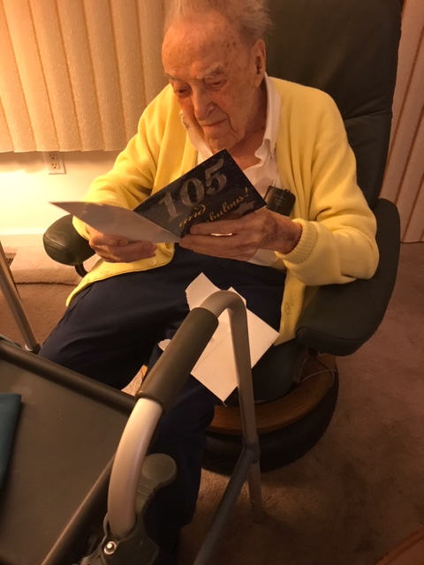
On a technical note, progress continues to be made on getting our main dome telescope up to snuff. Power outages and power spikes again scrambled the software and camera temporarily, and we are looking into a sturdier voltage regulator and UPS unit to help deal with these issues. Also, a checklist will be developed to make re-booting the system, when needed, easy for anyone using the scope. In addition, the scope is now set to use either eyepieces or a camera interchangeably, thanks to efforts by the WS observatory crew. We are closing on our ideal, usable configuration, and learning (by somewhat painful experience) where the pitfalls are, so we can deal with them when necessary.

As a practical result of the dome scope work, the main scope was usable for visual (eyepiece) viewing during the two September star parties, which is reassuring - as the weather gets colder, many people start to prefer indoor observing. Our star parties are doing well, but we can always use a little more help with them from our members. Please contact WSO director Charlie Burke if you think you can come and help, even on an irregular basis. For members not as familiar with the equipment, the regular WSO observatory crew are very good at showing you the ropes in very little time.

And as to the WSO dome’s future upgrade to remote operation, the beginning fundraising efforts have begun at the committee level, and quite soon the fundraising efforts will be launched publicly. The technical committee dealing with the dome upgrade will also be meeting soon, to determine the best overall solution.

Finally, at the coming (October 3rd) CCAS meeting, we will be visited by Mr. Mike Gyra of Barnstable HS and some of his astronomy students. Mike has a well-known and well-regarded astronomy program flourishing at Barnstable HS, and he will show us some of the highlights of that program at the beginning of our meeting.

Upcoming Speakers
October 3rd

Dr. Jim Lynch
President, CCAS
Senior Scientist Emeritus, WHOI

Title: Modern Galaxies – A Brief Overview

Abstract; Galaxies are some of the most spectacular and beautiful objects that we can observe, even through non-Hubble amateur telescopes. In this talk, I will try to give an overview of what modern galaxies are like, starting with their morphology (structure) and using our own Milky Way as an initial example. I will then talk a bit about the dynamics (motions) of our beloved barred spiral galaxy and its components. Not to be parochial, I will then move to other types of galaxies, such as ellipticals and irregulars. Finally, I will address assemblages of galaxies, going from the Local Group to the largest scales. If nothing else, this talk should include some really pretty pictures!

November 7th – Dr. Mark Reid, HSCfA

Topic: TBA

December 5th – Mr. Gary Walker, CCAS

Topic TBA

Last Month’s Speaker
September 5th
Dr. David Wilner
Associate Director
Radio and Geoastronomy Division
Center for Astrophysics | Harvard & Smithsonian
Title: New Eyes on Planet Formation
Abstract: To understand where the Earth comes from, we have to look beyond what's visible to the human eye. Using radio telescopes, we can now "see" directly the raw material for new planets orbiting around young stars and probe the process of planet formation in action. This talk will introduce some basic ideas and open questions about planet formation, from properties of our own Solar System that you can deduce from your own backyard to the latest advances from giant new radio telescopes, in particular new high resolution images from the international Atacama Large Millimeter Array (ALMA) of 66 precision antennas located at 16,500 feet altitude in northern Chile.
------
David’s lecture started out with a “popular science” reminder that in the famous 1960’s “Star Trek” series, the Enterprise was tasked to “find new worlds” long before the first exoplanet was discovered. We’ve always had a high degree of faith that other worlds were “out there.” Our faith has seemingly been vindicated – the current estimate is that there is roughly one planet per star in the Milky Way (and elsewhere). Since our galaxy has 200-500 billion stars (roughly), that’s a lot of planets!
It took a while, but not forever, for people to figure out that the planets traveled in approximately circular orbits around the Sun, that they were all in roughly the same plane (the ecliptic), and that the ecliptic plane and the Sun’s equatorial plane were the same! The Sun and the planets had a common origin! Kant and Laplace posed the basic model for how the solar system was born from a cloud of gas and dust, and we’ve been improving that model ever since.
David, being from HSCfA, had a beautiful set of images of “stellar nurseries” available to show us where, as you zoom in, the giant clouds become rotating protoplanetary discs and infant solar systems. These clouds take ~100 million years to form a solar system, but this is not so long given that our galaxy is about 12.6 billion years old, and the universe 13.7 billion years old!
A theme we have heard many times in lectures is that we are seeing more and more detail of how astrophysical processes work due to the tremendous advances that have been made in technology and instrumentation. These new instruments let us see both finer detail and more wavelengths of the electromagnetic spectrum, both key factors. A major new instrument for radio astronomy is the ALMA (Atacama Large Millimeter-submillimeter Array) in Chile. This reconfigurable 62 element array (50 12 m dishes and 12 7 m dishes) was created at a cost of $1.3 billion, and is producing some of the most exciting image data for astronomy to date. Two images that David suggested looking at online are HL Tau and TW Hya. Actually seeing planetary systems being born is one of the amazing products of these high-tech wonders.
As a parting note, David mentioned that, even though we have used the Solar System as a “prototype” for many years, we have found out that there are many differences between our own system and the new ones that we are finding “out there.” The “new worlds” are not just carbon copies of our world(s), but new indeed.

September Meeting Minutes and CCAS Business

The September business meeting was again rather brief, with a short update of where we were with the dome scope installation, a repeated call for dues, and an update on the upcoming dome automation project.

Star Parties

After August until mid-June, we will (generally) have two regularly scheduled Star Parties each month taking place at 7:30 -10:30pm on the Saturday closest to the date of First Quarter Moon (about 7 days old). This is an increase from our old schedule of one per month in the fall, winter, and spring.

From June through August, we have three regularly scheduled Star Parties each month taking place on Thursdays at 8:30-10:30pm.

When the moon is near its First Quarter, the terminator (the line dividing light from dark) is favorable for viewing sunlight or shadow on the sides of craters. This time is also favorable for observing the dark side of the moon occult (visually cover) stars in the sky as the moon moves in its orbit. Depending upon the calendar, we may also be able to observe planets and other celestial objects.

Here is the schedule for “Star Parties” up to January, 2020; the public is cordially invited!
October 19th, 26th
Nov 2nd
December 7th

POSSIBLE CANCELLATIONS for Star Parties: Cancellations will be very rare since we have lots to do "inside" as well as outside. Even if the forecast is "iffy"; the Staff Leader for the night may elect not to cancel in spite of possible clouds. If clouds arrive after staff and guests have convened, a virtual Star Party will usually take place indoors to include overviews of the sky for that night using computer simulations with our big screen TV, videos of interesting sky events recorded previously, demonstrations and/or training on the use of scopes and other equipment, and consultation/discussions on things astronomical, etc.

However, sometimes a solid forecast for overcast or rain or a storm will result in cancellation of a given Star Party. IF IN DOUBT ABOUT THE WEATHER AND THE STATUS OF A STAR PARTY, CALL THE OBSERVATORY AT 508-398-4765 AFTER 7:45 pm. No answer means the event has been cancelled.

Directions to Dennis Yarmouth HS and Schmidt Observatory

For information on the location of our Dome behind Dennis-Yarmouth High School, click on the purple button "Old Website" and once there, click on "Meeting Location" viewing the two maps that are there: external for the Dome, and internal to locate the high school library where meetings are held.

For meetings, drive in the south entrance road and go around behind the main building. Park in the lot about halfway down the building and go in the back door and turn down the hall to your left to find the library.

For Star Parties at the Dome, drive in the north entrance road all the way past the north side of the main high school building, through a gate, and on to park near our Dome.
H&K directions
Please be reminded that Gus Romano or his delegate host a dinner gathering for members and friends each CCAS meeting night (before the meeting) at the South Yarmouth Hearth & Kettle restaurant at 5:45pm; (the meetings begin at 7:30 at D-Y.) The speaker for each meeting is always invited. Please join the group to dine and talk about all things interesting, including astronomy, each month before our meeting. The H&K is at 1196 Rt 28, South Yarmouth, about a half mile west of the Station Avenue/Main Street intersection with Rt 28 (stop light).

