First Light Lite
October 4th, 2017
Jim Lynch, Mike Hunter, Gus Romano - Interim Editors
Website Committee
To repeat our usual message: our new website is coming along, and there is a wealth of information on it. In your browser, bring up www.capecodastronomy.org to see the latest info. We will continue to get updates from the committee at each monthly meeting.
Joel Burnett also has some important info on our old website:
"The original website may have some content of interest to you. I have added a link to it from our website www.capecodastronomy.org by going to "links" and then "vintage ccas".
You can also go directly to the site http://www.ccas.ws/oldwebsitetemp.html. Please gather what interests you from there as it will be retired on Dec 1st. If you feel any content there would be helpful to bring onboard to our new site, please contact cca@capecodastronomy.org and let us know. Also, if you have suggestions for the new site, please let us know that as well."
Communications Committee and Overall Efforts
After being dormant for a few months, our Communications Committee restarted its efforts with a conference call on July 26th. No September call was held, but Jim Lynch will be distributing written notes on "next steps" (including another conference call) for October. We hope, if you see these notes, you will see something you might like to do, and join our efforts.
If you are interested in joining in these efforts (which do not require great amounts of time), again, please email Jim Lynch at jlynch@whoi.edu. You can join in our (half-hourish) conference calls for free, and see if there is some facet of this work you would like to help with!

September CCAS Meeting Speaker
We’d like to thank Ms. Katie Sisson for giving the September talk on "Stellar Structure and Evolution." Katie did a great job of guiding the audience through the birth, life, and death of main sequence stars. A description of this talk can be found in our "meeting minutes" section below.

Upcoming Speakers and Topics

October 5– Mr. George Silvis, CCAS. "Rømer and the Speed of Light"
In 1676, Ole Rømer determined a value for the speed of light. Let's explore his methodology and see if we can understand and maybe duplicate his work. This will be a discussion of experiment design, O-C diagrams and model building. Probably part 1 of a 2 part presentation. I'm hoping this will be of interest to students looking for projects: I'll be putting source materials on the google drive and suggesting other investigations that can be done.

November 2 - Dr. Larry Marschall, Gettysburg College. "Tiny bit of shakin' going on: Gravitational waves and the universe."

On September 14, 2015, two unusual observatories, one in Louisiana and another in Washington State, recorded the near-simultaneous arrival of gravitational waves. This was the first time these subtle distortions of space had been detected, though their existence was predicted by Albert Einstein a century earlier. The discovery, perhaps the most remarkable and challenging astronomical measurement of the century, opened up a new way for astronomers to study the universe. We'll give some background on the nature of these odd ripples in the cosmos, and explain how, by observing changes on the earth's surface that are smaller than the nucleus of an atom, astronomers are now able to study some of the most powerful events in the universe-- the collisions of black holes millions of light years away.

December - Open…need a speaker! (Our two possible speakers had to be out of town!)

January – Dr. Frank Primini, HSCfA. Title TBA.

February - Dr. Kenneth Brink, CCAS. Title TBA

March - Dr. Jim Lynch, CCAS. Spectroscopy - Basics, with a demonstration.

April - Dr. Anastasia Fialkov, HSCfA. Fast Radio Bursts.

August CCAS Meeting minutes (Including Main Speaker talk precis)
Cape Cod Astronomical Society - Minutes of the September 9, 2017 meeting
Attendance: ~ 35
The meeting was held at the Dennis-Yarmouth High School Library.
-------------
September's speaker was Ms. Katie Sisson, CCAS. Her topic was: "Stellar Structure and Evolution."

Last month Katie Sisson took up the formidable topic of "Stellar Structure and Evolution." Restricting things to main sequence stars, and using some very compelling graphics, Katie went through the birth, life, and death of main-sequence stars.
This life starts in cold, giant molecular clouds, when gravity wins it war with pressure, and the cloud begins to collapse. These clouds typically have a composition of 70% hydrogen, 27% helium, and 3% other elements. This is mirrored in the star's initial composition.
A star like our Sun (see Figure 1), which is formed when the cloud has collapsed, has a heat generating core plus a "radiative zone" where the heat is transferred (slowly) from the core by electromagnetic radiation, typically over 100,000-200,000 years. This is due to the electrons in the dense, ionized plasma scattering the photons, so that they must take a prolonged "random walk" toward the surface. (The neutrinos that are created escape the core and the rest of the Sun easily, as they hardly interact with matter at all!) When the density becomes low enough, at the boundary of the radiative zone, transfer of energy by material convection (actual motion of the matter) becomes possible. This is in the outer ~1/3 of the Sun. The granules you see on the surface of the Sun are actually convective cells, where the bright part is rising hot gas, and the darks outer edges are falling gas that has cooled down near the surface.
The core, where the nuclear reactions that generate the energy occur, is an interesting place. It has a cozy temperature of 15 million degrees Kelvin, a density of 150 grams per cubic centimeter (water is 1 gram per cc), and is at a pressure of 340 billion atmospheres. Here the nuclear reactions take place, which Katie discussed next. (An interesting fact is that, per unit mass, the Sun's core produces heat at about the same rate as the human body, since the reactions proceed weakly through the "tails of the nuclear wavefunctions" via a process called "quantum mechanical tunneling." But since the core mass is concentrated, and moreover the energy cannot escape it quickly, the core becomes incredibly hot.)
The nuclear reactions in the Sun mainly occur via what is called the "proton-proton chain", and this is the typical route for small, low temperature stars. In larger, hotter stars, a catalytic route called the CNO cycle (carbon, nitrogen, oxygen) is also available. In this cycle, the CNO participates in the nuclear reactions, but is not consumed.

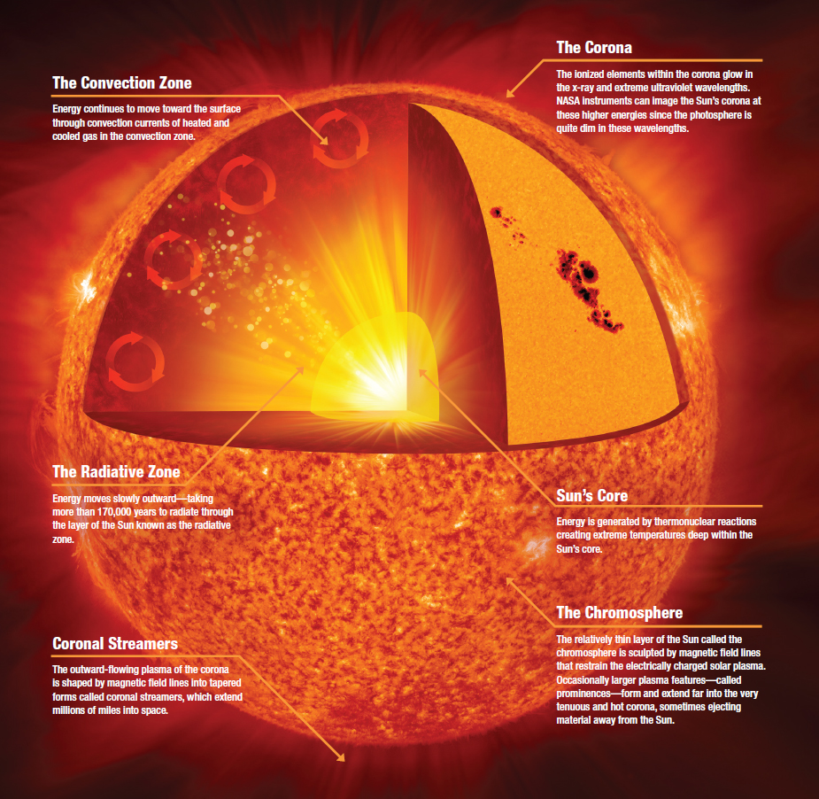
Figure 1. The structure of the Sun (courtesy NASA - freely distributable)

An interesting fact is that for stars smaller and cooler than the Sun (red dwarfs, for instance), there may not be any core or radiative zones, but only the convective zone! All stars don't necessarily have the same interior structure!
The second part of Katie's talk went from what a main sequence star's structure looks like to what a star's lifetime outlook is - it's evolution. This is typically shown in what has been dubbed the "Hertzprung-Russel (HR)" or "color-magnitude" diagram (which also can plot luminosity versus temperature, as these are all related.) A typical HR diagram can be found in Wikipedia, and is shown in Figure 2.

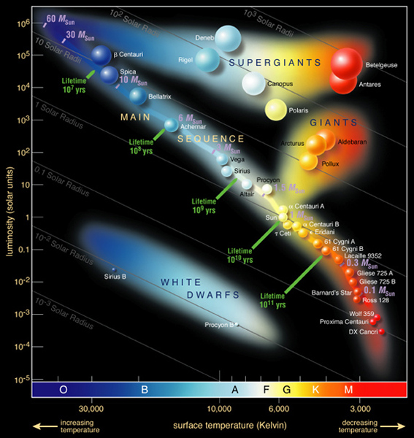
Figure 2. A typical Hetrzprung-Russel diagram (Courtesy Wikipedia - for CCAS use internal only, not distributable)

Typical stars have a well defined set of possible temperatures and luminosities during their lifetimes, defined primarily by what their initial masses are. The line from upper left to lower right is the so-called "main sequence", and our Sun can be found at luminosity=1 and type G, with temperature around 5600 degrees Kelvin. The main sequence is where stars are in "hydrostatic equilibrium", where the outward (radiation) pressure is balanced by the inward force of gravitational attraction. A main sequence star will stay there until its initial hydrogen fuel is largely exhausted. At that point, the star will expand and start to burn the helium that has been created in its core, with an outer shell of hydrogen also burning around it. The helium in the core will fuse into heavier elements (largely ones which have multiples of four nucleons, e.g. our familiar carbon and oxygen), as long as the star is large enough to support fusion. For lower mass stars, like our sun, oxygen is pretty much the end of the line as far as heavy element production is concerned. The Sun sheds its outer layers as it exhausts its fuel, becomes a red giant, and starts producing a beautiful planetary nebula, which will last for about 100,000 years. When all the fuel is exhausted, the remaining solar material collapses and shrinks down into a so called "white dwarf" star, about the size of the earth, which slowly cools down. The shrinkage of the white dwarf star is eventually halted, not by radiation pressure any more, but by a quantum mechanical effect called "electron degeneracy pressure," which is an expression of the Pauli Exclusion Principle. These stars are often rich in carbon and oxygen.
Larger (heavier) stars than the Sun follow a similar path, but with some interesting differences. These stars will produce elements up through iron in their cores. Past iron, it is energetically unfavorable to produce heavier elements. They also will become "bigger giants" as they age, and go up to the "supergiant" group on the HR diagram. Their death throes are also a bit different. A supergiant star, once it has exhausted all its fuel, and has a largely iron core, will suddenly and violently collapse, creating a "core collapse supernova." For medium large stars, this core collapse is halted by the protons and electrons combining into neutrons and neutrinos. The neutrinos escape easily (as always!), but the neutrons remain behind. These particles, like electrons, are spin 1/2 fermions, which obey the Pauli Exclusion Principle. This "quantum repulsion" creates a "neutron degeneracy pressure", similar to the electron pressure seen in white dwarfs. The star's core becomes a neutron star. The outer layers and neutrinos are blasted outward, with the release of 10^53 ergs of energy, which is more than our Sun will produce in its lifetime! Even larger stars will create a supernova and an even more exotic core end product - a black hole.
Katie ended her talk with a quote that matter plus energy plus physics equals the universe, and then took questions in a very lively session! The trick question of the day comes from her question session: how long does it takes photons from the core to transit the convective zone??

Business Meeting:

Vitaly, Paul, Joel and Hank shared their solar eclipse experiences (from Oregon, the Carolinas, Tennessee, and the Cape respectively) in a very entertaining session. It seems CCAS was very well represented, both locally and around the country!

Werner Schmidt turned 103 this last September. Many Happy Returns!!

The meeting was adjourned at 9:00pm.

Respectfully submitted,
Jim Lynch, standing in for our CCAS Secretary (who was the speaker)

Star Parties

Winter season once per month "QUARTER MOON SATURDAY STAR PARTIES”, all open to the public, begins September 23rd, 8:30-10:30PM.

From September thru June, we will have one regularly scheduled Star Party each month taking place at 8:30-10:30pm on the Saturday closest to the date of First Quarter Moon (about 7 days old).

From July through August, we will have three or four regularly scheduled Star Parties each month taking place on Thursdays at 8:30-10:30pm.

When the moon is near its First Quarter, the terminator (the line dividing light from dark) is favorable for viewing sunlight or shadow on the sides of craters. This time is also favorable for observing the dark side of the moon occult (visually cover) stars in the sky as the moon moves in its orbit. Depending upon the calendar, we may also be able to observe planets and other celestial objects.

Here is the remaining schedule for “Star Parties” through December, 2017; the public is invited:

Saturday, October 28

Saturday, November 25

Saturday, December 23

POSSIBLE CANCELLATIONS for Star Parties: Cancellations will be very rare since we have lots to do "inside" as well as outside. Even if the forecast is "iffy"; the Staff Leader for the night may elect not to cancel in spite of possible clouds. If clouds arrive after staff and guests have convened, a virtual Star Party will usually take place indoors to include overviews of the sky for that night using computer simulations with our big screen TV, videos of interesting sky events recorded previously, demonstrations and/or training on the use of scopes and other equipment, and consultation/discussions on things astronomical, etc.

However, sometimes a solid forecast for overcast or rain or a storm will result in cancellation of a given Star Party. IF IN DOUBT ABOUT THE WEATHER AND THE STATUS OF A STAR PARTY, CALL THE OBSERVATORY AT 508-398-4765 AFTER 7:45 pm. No answer means the event has been cancelled.

Directions to Dennis Yarmouth HS and Schmidt Observatory

For information on the location of our Dome behind Dennis-Yarmouth High School, click on the purple button "Old Website" and once there, click on "Meeting Location" viewing the two maps that are there: external for the Dome, and internal to locate the high school library where meetings are held.

For meetings, drive in the south entrance road and go around behind the main building. Park in the lot about half way down the building and go in the back door and turn down the hall to your left to find the library.

For Star Parties at the Dome, drive in the north entrance road all the way past the north side of the main high school building, through a gate, and on to park near our Dome.

H&K directions
Please be reminded that Gus Romano or his delegate “host” a dutch-treat dinner gathering for members and friends each CCAS meeting night (before the meeting) at the South Yarmouth Hearth & Kettle restaurant at 5:45pm; (the meetings begin at 7:30 at D-Y.) The speaker for each meeting is always invited. Please join the group to dine and talk about all things interesting, including astronomy, each month before our meeting. The H&K is at 1196 Rt 28, South Yarmouth, about a half mile west of the Station Avenue/Main Street intersection with Rt 28 (stop light).

