First Light Lite
July, 2019
Jim Lynch - Editor
June was a good month for equipment, but so-so for weather. After a very successful, last “winter/spring” Saturday star party on June 8th, the weather turned nasty on us for the remaining two (Thursday) summer star parties planned for that month. We are now officially on the summer schedule of three Thursday star parties per month, and hopefully will soon see some clearer skies. Working around the Cape’s weather still is one of our big hurdles.

Probably the biggest story for June was the installation of the new 12 ½” PlaneWave telescope in the WSO dome. From June 3rd on, the CCAF board and other CCAS members worked on getting the new scope set up, and perhaps the best thing to do right now is to let a few pictures tell the story!

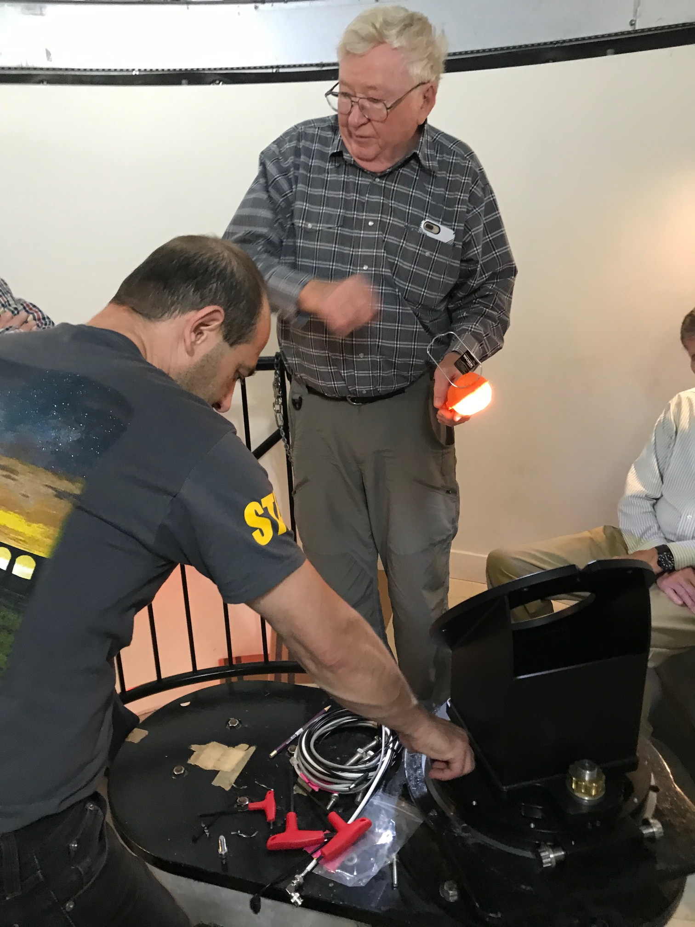

Mike Hunter and Tolga (from TolgaAstro, our vendor for the scope) work on installing the base of the new scope.

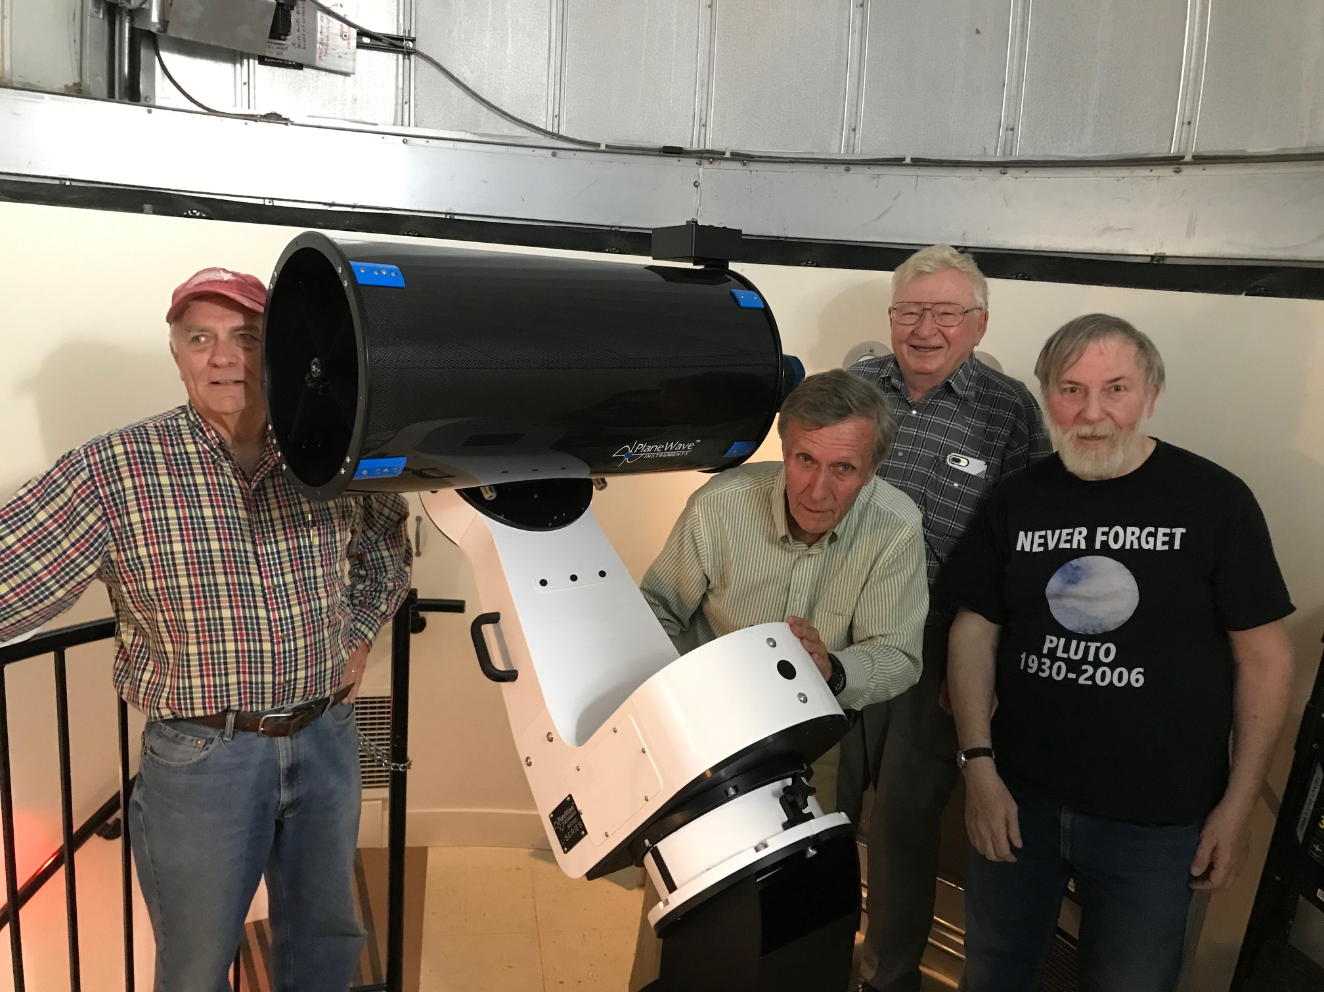

Gary Walker, Charlie Burke, Mike Hunter and Jim lynch huddle around the newly installed scope.

The “first light” picture the scope took, of M13, came out beautifully, with a 30 second unguided exposure giving beautiful, pinpoint stars. But, as I’m having trouble converting the FITS image file to a JPEG (yeah, it should be simple…), you’ll just have to believe me if you did not see this image at the last meeting. The scope is driven by magnetic motors, slews fast and silently, and points and tracks very accurately. Charlie Burke is developing a procedure sheet for using the scope, and it promises to be very much easier to deploy than the old 16”.

If things were actually so easy, this wouldn’t be astronomy, amateur or otherwise. After performing well at the installation, the auto focuser decided to give up the ghost, and Charlie Burke is now working with PlaneWave to get a replacement up and going quickly. We also bought an image splitter so that we can do both visual observation and photography. We have tons of eyepieces for visual, but we will probably get a new camera to best fit our new scope.

So the status on the scope summarizes to: we’re nearly there, with only a few last bugs to quash and gadgets to obtain. A big thanks goes to all those who made this new scope a reality! We will certainly get some very good use from it!

Changing topic, last month, a good version of our “projects” initiative was completed, and was attached to this newsletter. I also talked about it at our last meeting. Disappointingly, only two people have shown interest in such projects. I will try one more time to see if there is further interest, but if the response stays low, then so it goes. The people who are “mentors” will work with any interested folks, and I’ll keep this document and background material available for anyone who might be interested down the line!
Two important administrative details. First, dues are due in July, and are still a low $30 for a family, $15 for college students and part time residents, and free for HS students. We have been putting our dues money to good use for equipment and outreach, and hope that people will be willing to either start or continue as paying members of CCAS to support our efforts. You can bring checks (made to CCAS) or cash to the meeting, or send checks via snail mail to:
Dennis Yarmouth School District
Maintenance Department
Attn: Werner Schmidt Observatory
296 Station Ave
South Yarmouth, MA 02664
The second important detail is our upcoming elections, which will be held at the July meeting. As of now, the submitted names on the slate are my own (for President), Ashish Dutta (for Vice-President), and Katie Sisson (for Secretary). Mike Hunter has stated that he does not intend to run again for Treasurer. However, the current officers are not CCAS’ only election options, and it would be good to see a number of other names put forward on the slate. Names (your own or others) can be sent to jlynch@whoi and will be handled by Chris Lynch. Or you can propose a name at the July 11th meeting. CCAS officer is not exactly an onerous burden, and I’m hoping there will be some interest.
Lastly, let me reiterate last month’s plug, even before the usual FLL section on speakers, for the July and August speakers.
NOTE: On July 11th, and NOT July 4th which is the usual First Thursday, Dr. Larry Marschall of Gettysburg College will be talking about the New Horizons mission, and the views it provided of KBO’s Pluto and 2014 MU69 (aka Ultima Thule). This was a very hot news item during the last year, and Larry always gives great talks!
Also, in May I talked up the book “Einstein’s Monsters” by Chris Impey, which gives a very nice history of the VLBI (very long baseline interferometry) project to image a black hole. Another one of our favorite speakers, Dr. Tony Stark of HSCfA, was part of the South Pole Telescope group that manned that key instrument in the global VLBI array. He happily surprised me with an email saying that he would like to give a talk on that topic in August. (He also noted he was one of the 370 authors on the paper that reported the now famous image.)
So, we will have two of our best guest speakers talk about what were probably two of the hottest topics in astronomy over the last year! All I can say is “be there!!!!”

Upcoming Speakers and Topics
July (11th, not 4th!!!!!!)
Dr. Larry Marschall, Gettysburg College.
“ON BEYOND PLUTO”

Abstract: On New Year's Day, 2019, the New Horizons Spacecraft achieved a rendezvous with 2014 MU69, the most distant object in our solar system ever visited by a spacecraft. Three and a half years earlier, in July 2015, New Horizons made its closest approach to Pluto, sending back striking and informative closeup views of that distant dwarf planet. 2014 MU69 lies beyond Pluto, in a region of our solar system called the Kuiper Belt, and because of its immense distance, practically nothing is known about it. In this presentation, we will show some of the first glimpses of this previously unexplored region of space. Based on our experience with New Horizon's first views of Pluto, we expected many surprises, and there were----but there were also some remarkable confirmations of predictions. We'll discuss these both---data is still coming down from the distant spacecraft, and it won't all be downloaded until next year.

August 1st
Dr. Antony Stark, HSCfA
"Imaging Black Holes"
Abstract coming in July. See above for preview! 😊

Last Month’s Speaker
Dr. Jim Lynch – Astronomy Projects Initiative and New WSO Telescope

Since our June speaker had to cancel due to a travel conflict, JFL discussed the projects initiative and the new telescope installation. Most of the attention went to the new scope, which was installed on June 3rd , i.e. a few days before the CCAS meeting. Since I used my own computer for that presentation, I actually could show the M13 FITS image. I wish I could attach it here, but I don’t want to send out a large file.

June Meeting Minutes and CCAS Business

The past few business meetings have pretty much played the same tunes, with the telescope having the biggest part.

One addendum to the “new telescope installation saga” is that we have also gotten quotes for automating the dome for remote viewing. The (rough, conservative) bottom line is $9-15K to do this. This would be a game changer for us, in that we would have a LOT more observation time available (read any clear periods!), we could accommodate some of our more distant members (and there are a number all over the Cape), and the students would not be so restricted in their project work times. Janice Marks and Chris Lynch have signed up to do some “development” work to try to get funds for this initiative, and we will be posting more on it in the near future. Getting the new telescope up and running was the first step, and now that we nearing completion on that, we can start moving even further.

Jim Lynch also discussed pursuing membership more aggressively this year. We have made some progress with this initiative, but there is much more to be done.

Star Parties

From September until mid-June, we will have two regularly scheduled Star Parties each month taking place at 7:30 -10:30pm on the Saturday closest to the date of First Quarter Moon (about 7 days old). This is an increase from our old schedule of one per month in the fall, winter, and spring.

From mid-June through August, we have three regularly scheduled Star Parties each month taking place on Thursdays at 8:30-10:30pm.

When the moon is near its First Quarter, the terminator (the line dividing light from dark) is favorable for viewing sunlight or shadow on the sides of craters. This time is also favorable for observing the dark side of the moon occult (visually cover) stars in the sky as the moon moves in its orbit. Depending upon the calendar, we may also be able to observe planets and other celestial objects.

Here is the schedule for spring “Star Parties” up to August, 2019; the public is cordially invited:
July 18th and 25th (only two due to meeting and 4th of July conflicts)
August 8th, 22nd, and 29th

POSSIBLE CANCELLATIONS for Star Parties: Cancellations will be very rare since we have lots to do "inside" as well as outside. Even if the forecast is "iffy"; the Staff Leader for the night may elect not to cancel in spite of possible clouds. If clouds arrive after staff and guests have convened, a virtual Star Party will usually take place indoors to include overviews of the sky for that night using computer simulations with our big screen TV, videos of interesting sky events recorded previously, demonstrations and/or training on the use of scopes and other equipment, and consultation/discussions on things astronomical, etc.

However, sometimes a solid forecast for overcast or rain or a storm will result in cancellation of a given Star Party. IF IN DOUBT ABOUT THE WEATHER AND THE STATUS OF A STAR PARTY, CALL THE OBSERVATORY AT 508-398-4765 AFTER 7:45 pm. No answer means the event has been cancelled.
Directions to Dennis Yarmouth HS and Schmidt Observatory

For information on the location of our Dome behind Dennis-Yarmouth High School, click on the purple button "Old Website" and once there, click on "Meeting Location" viewing the two maps that are there: external for the Dome, and internal to locate the high school library where meetings are held.

For meetings, drive in the south entrance road and go around behind the main building. Park in the lot about half way down the building and go in the back door and turn down the hall to your left to find the library.

For Star Parties at the Dome, drive in the north entrance road all the way past the north side of the main high school building, through a gate, and on to park near our Dome.
H&K directions
Please be reminded that Gus Romano or his delegate host a dinner gathering for members and friends each CCAS meeting night (before the meeting) at the South Yarmouth Hearth & Kettle restaurant at 5:45pm; (the meetings begin at 7:30 at D-Y.) The speaker for each meeting is always invited. Please join the group to dine and talk about all things interesting, including astronomy, each month before our meeting. The H&K is at 1196 Rt 28, South Yarmouth, about a half mile west of the Station Avenue/Main Street intersection with Rt 28 (stop light).

