First Light Lite
January, 2020 Edition
Jim Lynch – Editor
Before anything else, let me wish you a Happy and Healthy New Year in 2020! We are looking forward to an exciting and educational coming New Year, and hope you will share it with us at CCAS.
------------
JANUARY MEETING TO BE HELD IN FALMOUTH PUBLIC LIBRARY
In order to “share the wealth” geographically, our January lecture and meeting will be held in Falmouth, MA, which is where the center of mass of our membership lies. This will be an occasional happening, and it will also let us see how well attended meetings outside of our usual DYHS venue are. (Being the day after New Year’s Day might also be a factor, but there is not much we can do about that!) I (JFL) will be the speaker, and will follow Gary Walker’s lecture on telescope cameras with a (hopefully) complementary lecture on telescope optics (see below).
The library address is 300 Main Street Falmouth. You go in the “meeting room entrance” across from Mullen Hall School, next to the Municipal Parking Lot (which gives us PLENTY of parking, similar to the DYHS lot). The library is right on Route 28 (which is called Main Street in Falmouth), so it is not very hard to find. Our usual pre-meeting dinner will be at Simply Divine, 271 Main Street (across from Library) at 545 PM. Talk, as usual, starts at 730 PM.
-------------
DOME REPAIR AND AUTOMATION PROJECT
Our dome repair and automation project is now beginning, with some repairs by Pappas Company planned for January 6th. Regarding fundraising, we have received $2,950 in initial funds and have $800 left in matching funds. This is towards the ~$10,000 we estimate that the project will take. The technical committee for the dome automation should be meeting soon, as well. Bit by bit, this project is becoming real!
-------------
OLD SCOPE SOLD, NEW CAMERA PURCHAS ED
As mentioned last month, the old 16” Meade scope was bought by the University of Nebraska. The purchase money went to the CCAF, which has used it for (among another things) a new CMOS color camera for the PlaneWave scope.
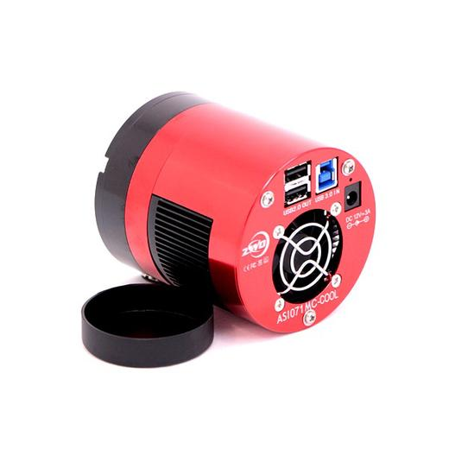

The camera, as pictured above, is a ZWO ASI071 Pro Cooled Color CMOS Telescope Camera. It is now installed at on the PlaneWave scope (along with an eyepiece for visual viewing), and is being put through its paces by Gary Walker and Charlie Burke.
-----------
STAR PARTIES – HELP ALWAYS WANTED!
This is a re-repeat paragraph from the last two months. Our star parties are doing well, aside from the usual Cape weather, but we really could use a little more help with them from our members. Please contact WSO director Charlie Burke if you think you can come and help, even on an irregular basis. For members not as familiar with the equipment, the regular WSO observatory crew are very good at showing you the ropes in very little time. The new scope is a lot easier to work with than the old scope, and it is fun to see operate!

-------------

SOME POSSIBLE FUTURE DIRECTIONS (CONTINUED)
A thought that had crossed my mind (inspired by the Mercury transit event collaboration with Barnstable HS) is to see if we can’t work more on a cooperative basis more of the HS programs on the Cape. Toward that, we have a special guest speaker (beyond our normal meeting schedule) lined up in mid-March with Barnstable HS, and are working to get participation with Sturgis and Sandwich HS as well. As details still are in the arrangement stage, I won’t say more now, but I should have information to relate next month.

Upcoming Speakers

Note: We currently have CCAS First Thursday speakers lined up through March. We now are looking for speakers for the 2020 schedule. If you are interested in giving a talk, or know someone who would be a good speaker, please contact Jim Lynch at jlynch@whoi.edu. Thanks!

January 2nd, 2020 (At Falmouth Public Library)

Dr. Jim Lynch, CCAS

Topic: Basics of Optics for Amateur Astronomers

ABSTRACT: Since Galileo, optics and optical instruments have been the "bread and butter" of astronomy. In this talk, I will go through the basic laws of reflection and refraction, the lens-makers' equation, the basics of telescopes, the diffraction limit, dispersion, optical gratings, and finally some modern optical physics. Some simple lab demonstrations will be included, time permitting.

February 6th, 2020
Dr. Ken Brink, CCAS
Topic: Oceans in Space

March 5th, 2020 (tentative)
Dr. Glen Gawarkiewicz, WHOI and Mr. Paul Fucile, CCAS and WHOI
CubeSats
Last Month’s Speaker
Mr. Gary Walker, CCAS
ABSTRACT: The world of Astro Imaging has seen several technology changes. The Author has experienced Tri-X film, push processing, Fuji 400, hyper sensitizing, CCD monochrome, colored filters, and now sCMOS. Many CCD chip manufacturers have shut down their factories--many to make space for new CMOS fab lines. Leveraging from the computer chip industry fabrication technology, CMOS chips offer small pixels, high speed, low noise, high dynamic range and most important, lower cost. While this works well for DSLR's, cell phone cameras, security cameras, and machine vision applications, how does this affect Astro Imaging? At the 2016 NEAIC, the word from vendors was that for the point and stare application of long exposures common to Astronomy, the CCD was still the detector of choice. The evolution of the CMOS technology may have closed the gap. The author investigates how CMOS can best be used for the point and stare applications that Astro Imagers need.

November Meeting Minutes and CCAS Business

The meeting portion of the evening consisted of a discussion of the status of the new telescope, and the purchase of a new camera.

Star Parties

After August until mid-June, we will (generally) have two regularly scheduled Star Parties each month taking place at 7:30 -10:30pm on the Saturday closest to the date of First Quarter Moon (about 7 days old). This is an increase from our old schedule of one per month in the fall, winter, and spring.

From June through August, we have three regularly scheduled Star Parties each month taking place on Thursdays at 8:30-10:30pm.

When the moon is near its First Quarter, the terminator (the line dividing light from dark) is favorable for viewing sunlight or shadow on the sides of craters. This time is also favorable for observing the dark side of the moon occult (visually cover) stars in the sky as the moon moves in its orbit. Depending upon the calendar, we may also be able to observe planets and other celestial objects.

Here is the schedule for “Star Parties” up to March, 2020; the public is cordially invited!
January 4th, 25th
February 1st, 22nd

POSSIBLE CANCELLATIONS for Star Parties: Cancellations will be very rare since we have lots to do "inside" as well as outside. Even if the forecast is "iffy"; the Staff Leader for the night may elect not to cancel in case of possible clouds. If clouds arrive after staff and guests have convened, a virtual Star Party will usually take place indoors to include overviews of the sky for that night using computer simulations with our big screen TV, videos of interesting sky events recorded previously, demonstrations and/or training on the use of scopes and other equipment, and consultation/discussions on things astronomical, etc.

However, sometimes a solid forecast for overcast or rain or a storm will result in cancellation of a given Star Party. IF IN DOUBT ABOUT THE WEATHER AND THE STATUS OF A STAR PARTY, CALL THE OBSERVATORY AT 508-398-4765 AFTER 7:45 pm. No answer means the event has been cancelled.

Directions to Dennis Yarmouth HS and Schmidt Observatory

For information on the location of our Dome behind Dennis-Yarmouth High School, click on the purple button "Old Website" and once there, click on "Meeting Location" viewing the two maps that are there: external for the Dome, and internal to locate the high school library where meetings are held.

For meetings, drive in the south entrance road and go around behind the main building. Park in the lot about halfway down the building and go in the back door and turn down the hall to your left to find the library.

For Star Parties at the Dome, drive in the north entrance road all the way past the north side of the main high school building, through a gate, and on to park near our Dome.
H&K directions (note January 2020 exception!)
Please be reminded that Gus Romano or his delegate host a dinner gathering for members and friends each CCAS meeting night (before the meeting) at the South Yarmouth Hearth & Kettle restaurant at 5:45pm; (the meetings begin at 7:30 at D-Y.) The speaker for each meeting is always invited. Please join the group to dine and talk about all things interesting, including astronomy, each month before our meeting. The H&K is at 1196 Rt 28, South Yarmouth, about a half mile west of the Station Avenue/Main Street intersection with Rt 28 (stop light).

