First Light Lite
Jan 1 2019
Jim Lynch - Editor
First, Happy New Year! I hope that 2019 brings all the best to you and yours, and is a happy, healthy year!
Second, let me take a crack at some New Year's "resolutions" for CCAS, combined with some discussion of where we are and where we might want to be. Please note that these are ideas only, and need to be discussed and, if deemed good, approved by CCAS members and/or the CCAF Board before anything is implemented!
2018 was a good year for CCAS and CCAF overall, I would say. Our speaker program was strong, with excellent monthly talks; our star parties kept up at a good pace, with a new Observatory director (Charlie Burke); and our DYHS honors program has kept momentum, with 14 students participating this fall. We also have a new main telescope ordered, to replace the aging 16" Meade scope, which has served CCAS well over a number of years, but now is past prime. Our membership has been stable, with even some small growth. The new website is up and running, and we have much better publicity for our events. We celebrated Werner Schmidt's 104th birthday with a very nice event at the dome. These are all good things to report, and I suspect I have even missed an item or two.
However, status quo is not what a club like ours should aspire to. There are many areas where we can advance, and indeed where we need to advance. Let me put out some suggestions about things we might consider. These are NOT any hard and fast directions, but rather my take. We will need to consider these things as a group.
As to our speaker program, I think the DYHS talks are doing just fine - but there are also great talks to be heard elsewhere, and I think we should try to get a schedule of them, and then organize club groups to go attend them (and mingle with the people giving them!)
Our star parties have also been fine (down to two per month in the winter, but away from the moon), but with the 16" dome scope being replaced, the indoor option, which is appealing especially in winter, will be offline for a couple of months. I think that focusing on binocular tours and small scope objects will hone those parts of the program for us, and be quite adequate until the new dome scope comes online. The winter sky has a LOT of first order bright things to see, many of which are ideal for wide angle binocular viewing. I also think that developing a good "standard spiel" about the objects we observe would improve the experience for visitors. Memorizing a few interesting facts about each object is not hard, and many of us already have quite a bit of this knowledge.
The DYHS program has continued this fall, but with two of its CCAS stalwarts having to step back due to personal reasons, we are in a "regrouping" phase with new projects and new personnel. We are planning a workshop soon with Jim Mitchell of DYHS to hone the projects a bit, and we also need 1-2 more people to step forward to help mentor the students.
The dome telescope replacement (more on that later in the letter) is now underway, and kudos to the CCAF Board for "scoping out" (pun intended) the possibilities and finding a good new instrument at a reasonable price, and with good technical support. This will be a very nice upgrade to our current capabilities. But, as with everything, I'd like to go even a bit further! And indeed, I think we eventually need to. The added improvement that I'd advocate is that we have both the dome and the scope automated for remote operation. The new scope software should be pretty good for this "out of the box", and so it really is mostly a dome upgrade. Yes, it would cost extra, but let me argue why it would be worth it.
The biggest plus is, very simply, usage! If members and students (with supervision) could use the scope on any clear night and later into the night from their homes, as opposed to coming on-site on the few clear nights we have star parties each month, usage would increase exponentially. Clear nights on the Cape are precious, and we miss the majority of them. This also would let our more remote members use the scope without a long drive. And if we could add photography and spectroscopy as options, member and student projects could be done that are currently just impossible with a limited schedule. This is NOT science fiction for a small club. Though it would take some thought, some money, and some effort, I think it would be incredibly worth it. I'd note that in the meantime, I'll be looking at iTelescope.net to see how well "pay per view" remote photography works via a commercial entity, and also look for ideas. (This service covers both the Northern and Southern hemispheres.)
Let me conclude this with a little note of caution - we are just at the feasibility study stage on this, and we don't want to over-promise what can be done. Let me just call the above a "wish list" for now.
Another thread that we need to pursue harder this year is recruitment of new members and member retention. We are planning an "Alumni and Newcomers" event for spring, which we will put some effort and money into, and which we might perhaps coordinate with a "First Light" event for the new scope. We are also giving lectures at various venues to see if we can attract more people. As to retention, we really need to consider how we will engage ALL of our members in some activity where they will be both continually interested and also contribute to the club. Our VP, Ashish Dutta will be in charge of this initiative, and will be coordinating efforts.
That's enough for one newsletter, but is not all the topics we can consider for the New Year. The website and our outreach/advertising can be discussed next time. There is plenty to do, and this list is just a start.

Upcoming Speakers and Topics

January, 2019 Mr. Hugh Blair-Smith, The Apollo Missions
What made the Space Race possible? What made it necessary? How close a race was it? And what did it achieve? The answers involve the history of three technologies—rockets, navigation, and computers—and how they were woven together by systems engineers to make Apollo and the Space Shuttle, significant contributions to winning the Cold War.
Author Hugh Blair-Smith, a part-time Cape Codder since 1946 and full-time since 2005, was a staff engineer at MIT’s Instrumentation (later Draper) Laboratory from 1959 through 1981. He and many colleagues created one answer to the long-sought quest for “a moral equivalent to war.” He appeared in a Nova show, Apollo’s Daring Mission, on December 26, 2018, at 9 PM EST—celebrating the 50th anniversary of Apollo 8, the first to place men in orbit around the Moon. (You can still catch this excellent show on Nova - it is still available.)
February - Dr. Jim Lynch CCAS, "The Formation of the First Stars and Galaxies - Dr. Loeb's Book Simplified for Us Amateurs"
March - Speaker TBA
April - Dr. Charles Lada, HSCfA, Topic TBA
May - Speaker TBA
June - Dr. Marion Dierickx, HSCfA, Topic TBA

Last Month's Speaker

December 6 - Dr. Jim Lynch, CCAS. "The Solar System - Its Formation and Basic Dynamics."

In this talk, I went through some of the basic concepts of solar system dynamics that are needed to explain the formation and development of the Solar System as we see it today. Kepler's Laws and Newton's Laws are the "oldies but goodies" that all amateurs know, but things get even more interesting (and more complicated) from there. Laplace and tides, resonances, nonlinear dynamics and chaos, and modern computer modeling have moved solar system studies into the modern age. These concepts were described using simple examples. With these mathematics and physics tools, astronomers have been able to piece together a plausible, if still somewhat incomplete, picture of how our Solar System formed, how it is evolving, and what its eventual fate may be. In that satellite and other observations of the Solar System is a huge topic in itself, I concentrated more on the theory and computation concepts than on the observations in this talk. But I hope that someone will pick up the observational thread in the not-too-distant future!

Addendum: November 1 - Dr. Martina Arndt, Bridgewater State University, "The Beauty and Science of Total Solar Eclipses"

I again owe an apology, in that I belatedly asked Dr. Arndt for her slides/notes late in the month, to use as a guide for our usual precis of the speaker's talk. While I did a small precis last month, I think I missed highlighting some of her more striking slides. Let me correct that here. (As Dr. Arndt requested that her slides not be distributed, I will just verbally discuss them here.)
The slide showing the Moon both at apogee and perigee was a nice way to show why we see both full and annular eclipses…numbers talking about solid angles are nice, but this type of slide (typical in Martina's talk) was visceral.
The "Calendar slide" showing the recurrences of eclipses versus year and month was also striking…one could clearly see how the 5 degree tilt of the Moon's orbit relative to Earth's orbit made the eclipses occurrence roughly bi-yearly, rather than monthly.
The picture of the 2015 eclipse corona was an especially striking one, in which the magnetic field lines are amazingly prominent.
The iron and argon spectroscopy were a bit of my favorite, as one can study the temperature and density of the corona by how various elements are ionized versus distance from the Sun's surface. This was part of the science story that Dr. Arndt and her team will be publishing.
And again, the travelogue was as much fun as the science…eclipse hunters get to go to some pretty exotic spots!

December Meeting Minutes and CCAS Business

Mike Hunter and Gus Romano gave a detailed update on the status of our main observatory telescope replacement. I'll let the pictures do the talking here.

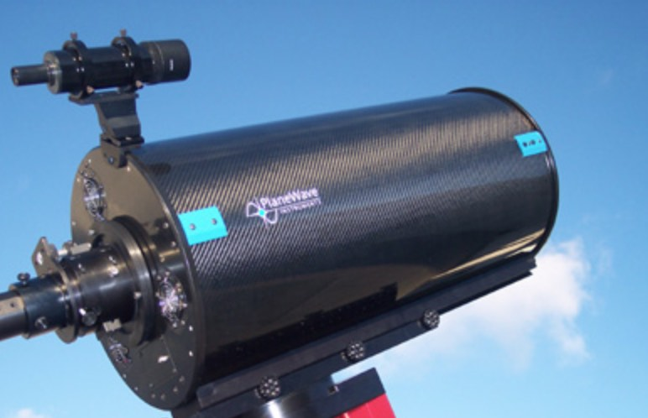

Fig. 1. The PlaneWave 12.5 inch scope we are purchasing

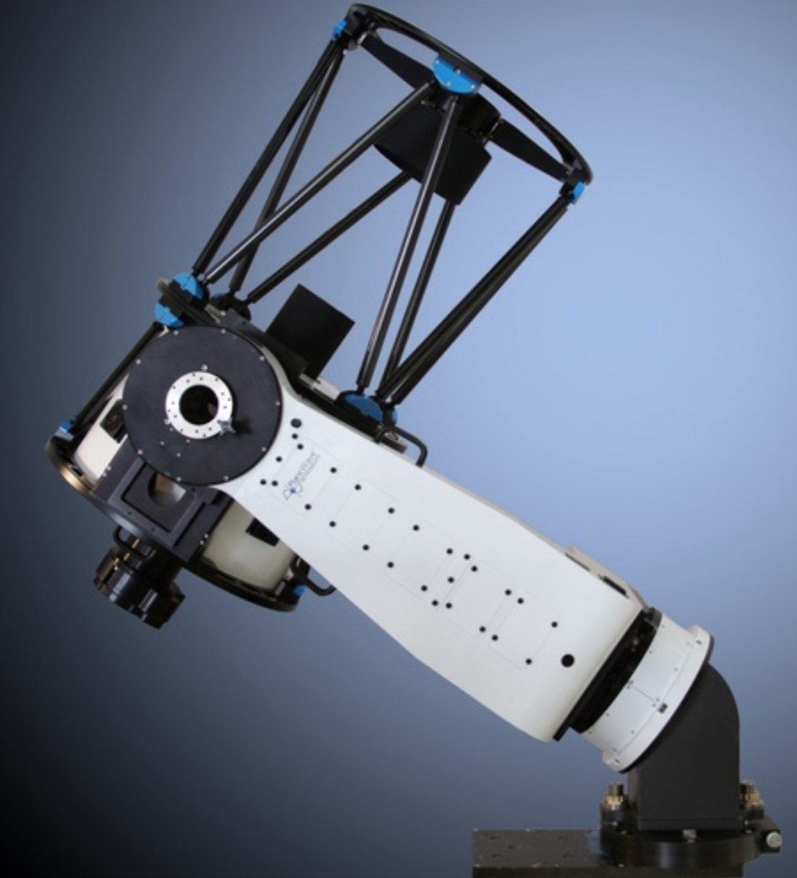

Fig. 2. Our new mount, with one scope on it, and tilting wedge

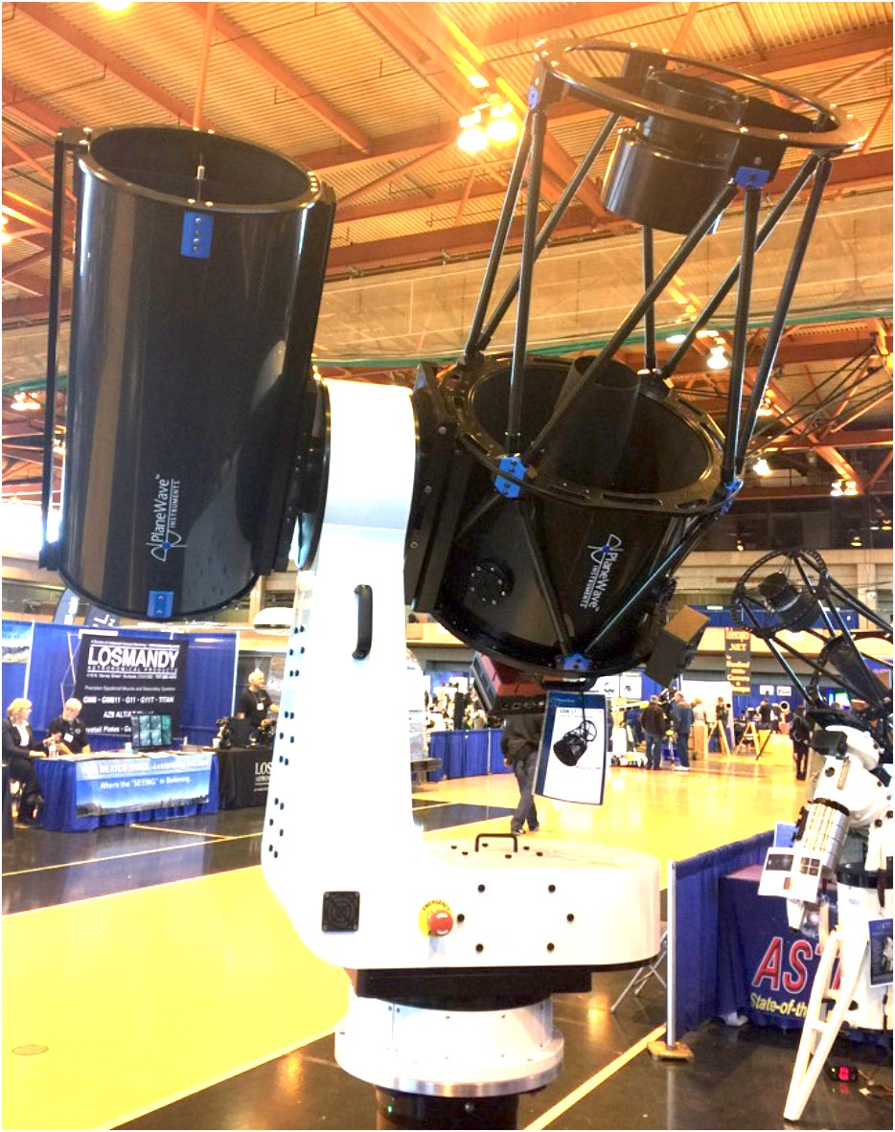

Fig.3. Our new mount, holding two scopes simultaneously (as we will do), but without the wedge

Star Parties

From September thru June, we will have two regularly scheduled Star Parties each month taking place at 7:30 -10:30pm on the Saturday closest to the date of First Quarter Moon (about 7 days old). This is an increase from our old schedule of one per month in the fall, winter, and spring.

From July through August, we have three regularly scheduled Star Parties each month taking place on Thursdays at 8:30-10:30pm.

When the moon is near its First Quarter, the terminator (the line dividing light from dark) is favorable for viewing sunlight or shadow on the sides of craters. This time is also favorable for observing the dark side of the moon occult (visually cover) stars in the sky as the moon moves in its orbit. Depending upon the calendar, we may also be able to observe planets and other celestial objects.

Here is the schedule for winter “Star Parties” up to February, 2019; the public is cordially invited:
January 5th and 12th
February 2nd and 9th

POSSIBLE CANCELLATIONS for Star Parties: Cancellations will be very rare since we have lots to do "inside" as well as outside. Even if the forecast is "iffy"; the Staff Leader for the night may elect not to cancel in spite of possible clouds. If clouds arrive after staff and guests have convened, a virtual Star Party will usually take place indoors to include overviews of the sky for that night using computer simulations with our big screen TV, videos of interesting sky events recorded previously, demonstrations and/or training on the use of scopes and other equipment, and consultation/discussions on things astronomical, etc.

However, sometimes a solid forecast for overcast or rain or a storm will result in cancellation of a given Star Party. IF IN DOUBT ABOUT THE WEATHER AND THE STATUS OF A STAR PARTY, CALL THE OBSERVATORY AT 508-398-4765 AFTER 7:45 pm. No answer means the event has been cancelled.

Directions to Dennis Yarmouth HS and Schmidt Observatory

For information on the location of our Dome behind Dennis-Yarmouth High School, click on the purple button "Old Website" and once there, click on "Meeting Location" viewing the two maps that are there: external for the Dome, and internal to locate the high school library where meetings are held.

For meetings, drive in the south entrance road and go around behind the main building. Park in the lot about half way down the building and go in the back door and turn down the hall to your left to find the library.

For Star Parties at the Dome, drive in the north entrance road all the way past the north side of the main high school building, through a gate, and on to park near our Dome.
H&K directions
Please be reminded that Gus Romano or his delegate “host” a
Dutch-treat dinner gathering for members and friends each CCAS meeting night (before the meeting) at the South Yarmouth Hearth & Kettle restaurant at 5:45pm; (the meetings begin at 7:30 at D-Y.) The speaker for each meeting is always invited. Please join the group to dine and talk about all things interesting, including astronomy, each month before our meeting. The H&K is at 1196 Rt 28, South Yarmouth, about a half mile west of the Station Avenue/Main Street intersection with Rt 28 (stop light).

