First Light Lite
Feb 4, 2019
Jim Lynch - Editor
Well, it's winter. Beautiful bright constellations with plenty of observable objects, and the clearest nights of the year. The price to be paid is dealing with cold, ice and snow. And of course clouds…after all, this is Cape Cod.
January has not been especially kind to our star parties, in that both were cancelled due to weather (though the skies did clear later for our second one). The Super Blood Moon of January 21st, which would have been a good WSO viewing event, was left off the calendar due to both its lateness and possible icy road condition concerns. (Safety always comes first!) We hope that our members had their cameras ready for that event, and look forward to seeing some good pictures if someone got a break in the clouds.
These weather cancellations really do underscore that we need some remote capabilities for observing ( "partially remote" to begin with, i.e. manual dome operation). As detailed last month, our new telescope is on its way, and we are also looking at the feasibility of making the dome fully remote down the line.
On another front, our DY HS honors program mentors met with Jim Mitchell on January 5th to discuss upgrades and changes to the program. The results of that meeting were that: 1) we need a few more mentors from CCAS, 2) we need some more new, pre-tested projects to offer (as some of the untested ones from seemingly good sources didn't work out so easily or well), 3) we might look at just asking students to do one "sky tour" night at WSO, and have pre-canned data for the projects, as it is hard to accommodate students schedules, clear skies, and our relatively infrequent star parties, 4) perhaps remote facilities such as iTelescope.net or AAVSO's facilities could be used to get data, and 5) perhaps some of the "citizen science" sites like Zooniverse could be looked at for projects. Mr. Mitchell also had some ideas about how to better interact with students from the teacher's point of view. All in all, it was a productive meeting, and the group will have a follow up meeting in another two months.

Upcoming Speakers and Topics

February, 2019 Dr. Ken Brink, WHOI/CCAS
Plasmas and Their Role in the Cosmos
Plasmas are the fourth state of matter, along with solids, liquids and gases. A plasma is essentially a gas that is so hot that electrons separate from their normal atoms, leaving a gas composed of both negatively charged electrons and positively charged ions (atoms missing one or more electrons). Given the wealth of charged particles, plasmas such as lightning are far better carriers of electrical currents than are normal gases. The presence of charged particles means that plasma properties depend strongly on ambient magnetic fields, and the plasma, in turn, can create its own magnetic effects. The strong dependence on the electromagnetic environment, combined with the usual properties of fluid flow, means that plasma flows are often turbulent and very complex. Cosmic examples of plasmas to be discussed include the solar wind, the aurora borealis, stellar interiors, and accretion disks. Plasmas are believed to be the most common type of non-dark matter in the universe.
March - Dr. Jim Lynch CCAS, "The Formation of the First Stars and Galaxies - Dr. Loeb's Book Simplified for Us Amateurs"
April - Dr. Charles Lada, HSCfA, Topic TBA
May - Mr. Jim Mitchell and DYHS Students - Astronomy Honors Program
June - Dr. Marion Dierickx, HSCfA, Topic TBA

January's Speaker Mr. Hugh Blair-Smith "The Apollo Missions"

What made the Space Race possible? What made it necessary? How close a race was it? And what did it achieve? The answers involve the history of three technologies—rockets, navigation, and computers—and how they were woven together by systems engineers to make Apollo and the Space Shuttle, significant contributions to winning the Cold War.
Author Hugh Blair-Smith, a part-time Cape Codder since 1946 and full-time since 2005, was a staff engineer at MIT’s Instrumentation (later Draper) Laboratory from 1959 through 1981. He and many colleagues created one answer to the long-sought quest for “a moral equivalent to war.” He appeared in a Nova show, Apollo’s Daring Mission, on December 26, 2018, at 9 PM EST—celebrating the 50th anniversary of Apollo 8, the first to place men in orbit around the Moon. (You can still catch this excellent show on Nova - it is still available.)

Forgive me if I reposted Hugh's abstract again, but it is a good precis of the very detailed talk he gave about the history of the space program, which is somewhat of an old favorite for the CCAS crowd (which could be gleaned by the excellent turnout!) The talk was excellent, well polished, and that for many of us "older demographic" CCAS members, brought back many memories, as well as provided some great insider insights. And again, catch the Nova show if you can! Hugh has some good bits in it, and the overall production is typical of Nova's high standards.

January Meeting Minutes and CCAS Business

Mike Hunter and Gus Romano gave the latest update on the status of our main observatory telescope replacement. We're looking at about three months (guesstimate) for the new scope to be installed, and then we will be training a core of people to use it. If you haven't seen the scope and mount pictures last month, I'll again post the pictures here.

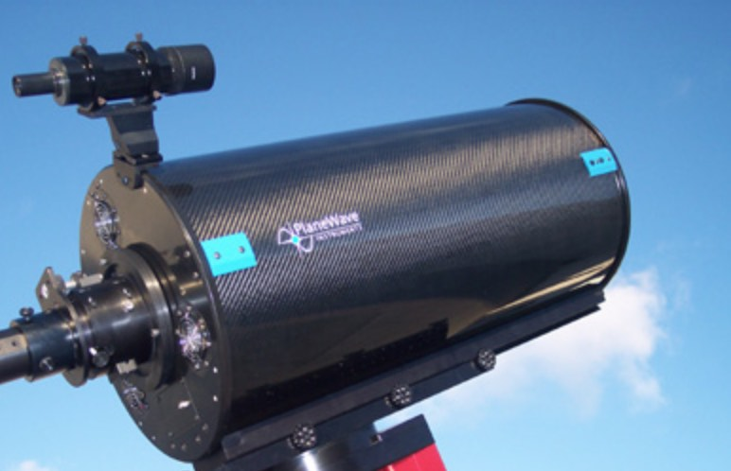

Fig. 1. The PlaneWave 12.5 inch scope we are purchasing

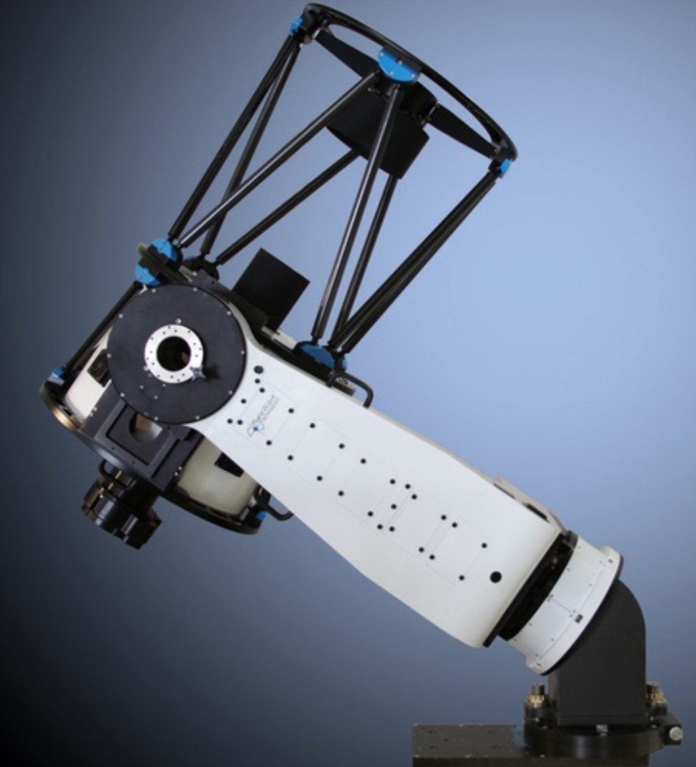

Fig. 2. Our new mount, with one scope on it, and tilting wedge

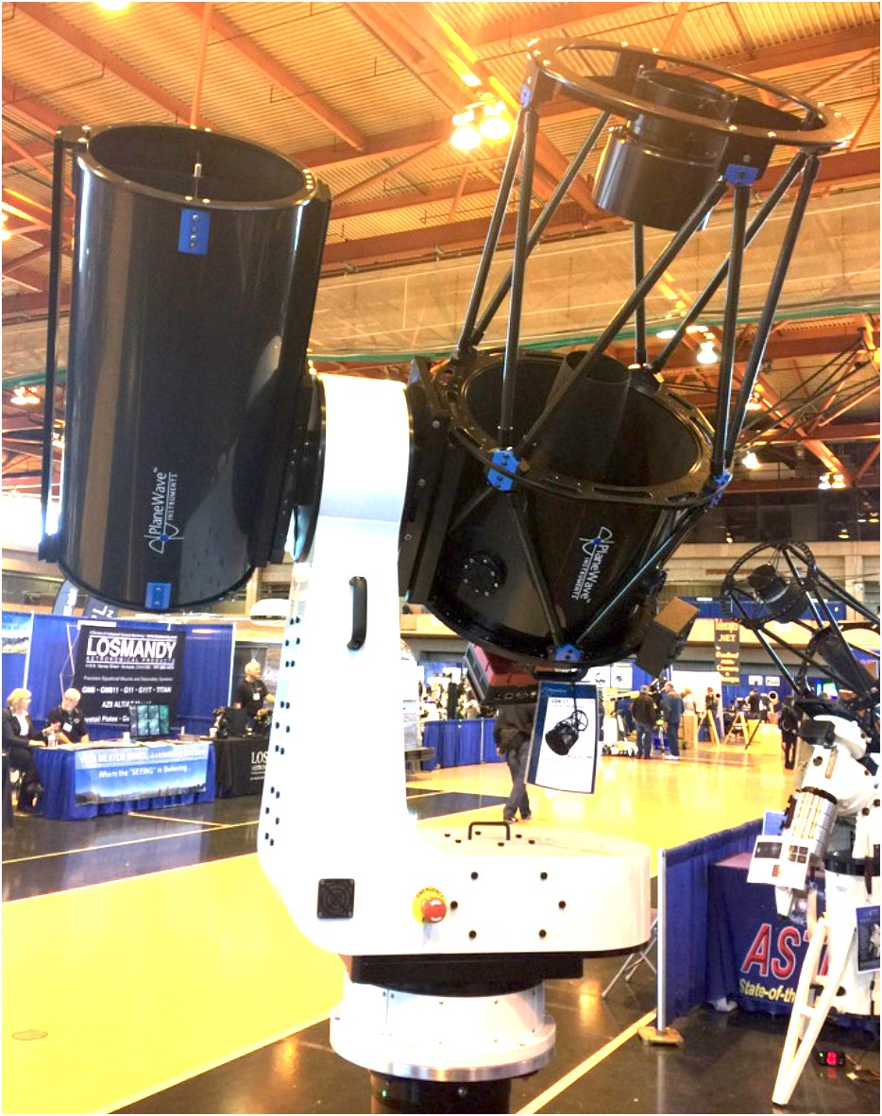

Fig.3. Our new mount, holding two scopes simultaneously (as we will do), but without the wedge.
Star Parties

From September thru June, we will have two regularly scheduled Star Parties each month taking place at 7:30 -10:30pm on the Saturday closest to the date of First Quarter Moon (about 7 days old). This is an increase from our old schedule of one per month in the fall, winter, and spring.

From July through August, we have three regularly scheduled Star Parties each month taking place on Thursdays at 8:30-10:30pm.

When the moon is near its First Quarter, the terminator (the line dividing light from dark) is favorable for viewing sunlight or shadow on the sides of craters. This time is also favorable for observing the dark side of the moon occult (visually cover) stars in the sky as the moon moves in its orbit. Depending upon the calendar, we may also be able to observe planets and other celestial objects.

Here is the schedule for winter “Star Parties” up to February, 2019; the public is cordially invited:
February 2nd and 9th

POSSIBLE CANCELLATIONS for Star Parties: Cancellations will be very rare since we have lots to do "inside" as well as outside. Even if the forecast is "iffy"; the Staff Leader for the night may elect not to cancel in spite of possible clouds. If clouds arrive after staff and guests have convened, a virtual Star Party will usually take place indoors to include overviews of the sky for that night using computer simulations with our big screen TV, videos of interesting sky events recorded previously, demonstrations and/or training on the use of scopes and other equipment, and consultation/discussions on things astronomical, etc.

However, sometimes a solid forecast for overcast or rain or a storm will result in cancellation of a given Star Party. IF IN DOUBT ABOUT THE WEATHER AND THE STATUS OF A STAR PARTY, CALL THE OBSERVATORY AT 508-398-4765 AFTER 7:45 pm. No answer means the event has been cancelled.

Directions to Dennis Yarmouth HS and Schmidt Observatory

For information on the location of our Dome behind Dennis-Yarmouth High School, click on the purple button "Old Website" and once there, click on "Meeting Location" viewing the two maps that are there: external for the Dome, and internal to locate the high school library where meetings are held.

For meetings, drive in the south entrance road and go around behind the main building. Park in the lot about half way down the building and go in the back door and turn down the hall to your left to find the library.

For Star Parties at the Dome, drive in the north entrance road all the way past the north side of the main high school building, through a gate, and on to park near our Dome.
H&K directions
Please be reminded that Gus Romano or his delegate “host” a
Dutch-treat dinner gathering for members and friends each CCAS meeting night (before the meeting) at the South Yarmouth Hearth & Kettle restaurant at 5:45pm; (the meetings begin at 7:30 at D-Y.) The speaker for each meeting is always invited. Please join the group to dine and talk about all things interesting, including astronomy, each month before our meeting. The H&K is at 1196 Rt 28, South Yarmouth, about a half mile west of the Station Avenue/Main Street intersection with Rt 28 (stop light).

