First Light Lite
December 1, 2021 (though sent a few days early! Happy Thanksgiving!)
Jim Lynch – Editor
Message from the CCAS President
This month was very different from the past twenty or so, in two significant ways. First, we were able to hold our first in-person Star Party at the Werner Schmidt Observatory, albeit fully outdoors due to Covid protocols. And second, we were able to participate in a face-to-face (well, mask-to-mask) indoor event at the Cape Cod Natural History Museum. Both events were done cautiously, as mentioned. The big message is that they were indeed held, and both went very nicely. The Covid pandemic is not over, but at least for a highly vaccinated and cautious area like the Cape, some normal activities are resuming. I’ll talk further talk about both below.

1) Ramping Up Our Activities (mandatory Plan B update)
Lecture series
We have some more great speakers lined up (see below) and will be continuing our book give-away program for any students attending. Live lectures look increasingly unlikely right away (until after February at the earliest is our latest guess). We generally use public venues for our talks, and these are still not fully opened. We’re hoping that after the “winter/Holiday spike,” which seems to be a very real phenomenon, things will ease up. We’ll keep you informed.
Star Parties (updated)
Our WSO star parties were shut down for over a year and a half during the pandemic, but we are now getting back into business. We are now able to host outdoor events at the Werner Schmidt Observatory (WSO) on the DYHS campus grounds. Though our first star party, scheduled for October 30^{th,} was cancelled due to weather, the November 6th star party was held, and attracted numerous visitors. It was planned to be a combination of “Electronically Assisted Astronomy,” with our main scope and a small outdoor telescope producing images on large screens outdoors, and a laser pointer and binocular sky tour. The large scope had problems that were only fixed towards the end of the party, but the images finally produced were quite nice, and one is shown below. Both the large (12”) and small (8”) scopes should be ready to show outdoor images by our next star parties, which are now postponed until the cold weather abates (see below). The binocular and laser tour went quite well, with three planets, the Milky Way, and a plethora of constellations (and their attractions) showing up brightly. Late fall and winter occasionally have very clear skies!
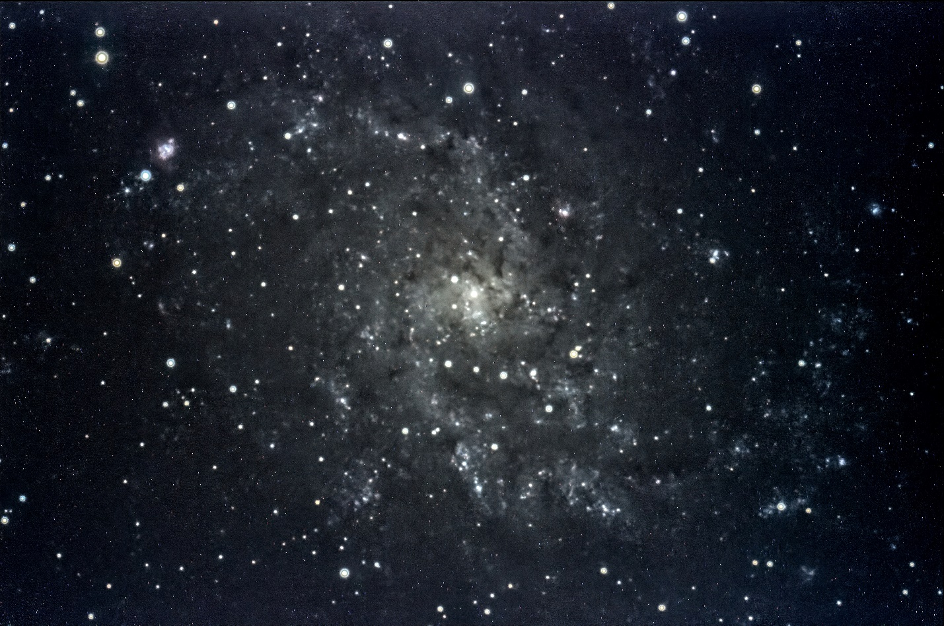
Fig 1. M33 in Triangulum (located just below the bright star Mirach in Andromeda). This galaxy is an object that is hard to see any detail in with binoculars, but shows up very nicely using a short time exposure on our main telescope.
As to the resumption of Star Parties, the cold weather has now become a controlling factor. We can’t allow people into the WSO to warm up yet, and as the December, January, and February evening weather is very often 20-30 degrees (plus wind chill), we don’t want to freeze our guests (or our staff). So, we will work on getting our equipment and Observatory in great shape for the Spring. Additionally, we will post some winter sky attractions to look at in our newsletter and on the web. You can (like I do) duck in and out of your warm house to see these or photograph them. The dates for further 2021 Star Parties which are posted on the CCAS website, www.capecodastronomy.org, will be removed and we will update that site with the 2022 Star Party dates as soon as possible.
School Projects and Activities
At this point in time, we are still discussing with the local schools (DYHS, BHS, Sturgis) what is possible and what is not this winter and spring.
Public Outreach
As mentioned, we had a very successful CCAS booth at the Cape Cod Natural History Museum on November 13th, when the Museum hosted a “James Webb Space Telescope” event that concentrated on space science and astronomy. Jim Lynch, Chris Lynch and Charlie Burke staffed the booth, which had many visitors (picture shown below). We had many people sign our “interest” sheet, and also take our brochures, and so hopefully we will be seeing these people again in the future! We also heard a great lecture on the Webb telescope by Charles Law of the Harvard Smithsonian Center for Astrophysics, who also has agreed to give that talk to us in January!
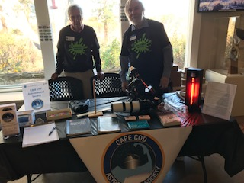
Fig. 2. Charlie Burke and Jim Lynch man the CCAS booth at the CCNHM “James Webb Space Telescope” event. The red glow is a neon gas discharge tube that we used to show spectroscopy (together with inexpensive diffraction grating slides). Photography by Chris Lynch.
Day of Astronomy
We are still planning a Day of Astronomy event at the Werner Schmidt Observatory (WSO) for the public and our club members and friends. However, it also will have to wait for warmer weather, as we’d like to have indoor events, and because the outdoor component will just be too cold for a multi-hour event (as with our star parties.)
We will send out notices (email and other) when the date for this solidifies, as well as post it on our web calendar.

2) Speakers

Last Month’s Speaker
November 4th, 2021
Dr. Daniel Davis, Stony Brook University
ABSTRACT
Turning Left for Three Decades: Still Gazing After all These Years
In an era with go-to telescopes and equipment that allows amateurs to image the sky better than professionals could just a few decades ago, there is still a place for star-hopping and simple visual observing.
In this presentation, Dan Davis will talk about the fun (and occasional mishaps) encountered in creating the various iterations of the book Turn Left at Orion with his friend Guy Consolmagno. To explore the night sky, even in the presence of light pollution, doesn’t require fancy equipment or arcane knowledge. There are wonderful things to see with even the smallest telescopes – you just need to know where to look and what to look for. It isn’t hard to find your way around the sky but doing so can be very rewarding and inspiring. Above all, it should be fun.
BIOGRAPHY
Dan Davis is a geophysicist and a member of the faculty at Stony Brook University on Long Island – but next year he will retire and move to the Boston area. His main area of research for much of his career has been the mechanics of plate collisions and the mountain belts formed by them, and he has also worked on the geology and geophysics of nuclear arms control. Most recently, he and his students have applied geophysical tools to the study of the shallow subsurface of Long Island and its recent glacial history. A lifelong amateur stargazer, he is co-author of a book on amateur astronomy, Turn Left at Orion (from Cambridge University Press). Now in its 5th edition (and 4th language), the book has sold over 180,000 copies.

PRECIS
Dan Davis is a professional geophysicist, though he’s been called a geologist quite a few times, and doesn’t seem to faze him. But he’s also, like many other scientists, a stargazer in his spare time. The sky attracts us all, even those who concentrate on other sciences.
And like many hobbyists, Dan undertook writing a book about his hobby. The talk he gave us was about both his hobby and the story of writing his book, “Turn Left at Orion,” which he co-authored with his friend and colleague Brother Guy Consolmagno.
The talk started out with a slide about something we are all too aware of on the Cape, light pollution. A color map of night light pollution in the US show the Eastern half of the country being by far the worst polluted, with the BosWash corridor being exceptionally bad. Sadly, this is not news to most of us.
But, even in the presence of such an obstacle, intrepid amateurs with small telescopes and light pollution filters (that you just screw onto the eyepiece) can see many of the wonders of the night sky, and Dan Davis was among them from the time he was young. He showed some of the detailed drawings he made of Mars and the globular cluster M13, and they were quite good and very detailed. (Dan joked that he is so detail oriented that he worries if anal retentive is spelled with a hyphen or not.)
Time marched on, and Dan marched with it through the corridors of MIT, where he obtained his PhD degree in 1983. While there, he made the acquaintance of Brother Guy, who had obtained his BS there a few years earlier. Their friendship has lasted many years since, and as mentioned generated their book. However, before the book, Brother Guy took off for Africa and the Peace Corps and Dan, wanting his friend to enjoy the beauty of the skies when traveling, made sure his friend had a small scope and also tables of coordinates for the best sky objects. And therein starts the tale.
Celestial coordinates are great things for professional astronomers and amateurs with go-to scopes, but not so useful if you don’t know your way around the night sky and are looking manually. “Turn Left at Orion” was what Dan told Guy (more or less) to instruct him how to get to an object of interest (Beta Monoceratis) simply. And the thought struck them – how about writing a guide for those who would like to star-hop with a simple scope, and not worry about the intricacies of go-to scopes and other such technology? The idea took hold.
Writing a book, any book, means finding a willing publisher, and as any author will tell you, that is not always easy. Dan’s and Guy’s first attempts failed, as expected. However, an enquiry to the highly respected academic book publisher, Cambridge University Press, did produce a positive result, the courtesy (they later found out) of one Sir Patrick Moore, one of the major heroes of amateur astronomy. The book was on its way!
Now the fun part began. Using his 2.4” refractor, Dan listed and observed his 100 favorite sky objects, and to ensure that the list was accessible to a somewhat less expert observer, had Guy check these with his 3.5” Maksutov. Numerous galaxies, clusters, doubles, nebulae and reams of detailed notes later, the first edition of “Turn Left at Orion” appeared.
In the next part of the talk, Dan showed some of his favorite objects from the book, the evolution of the book over several editions, and a bit of a travelogue including the Vatican and Australia. At the Vatican, he got to swipe (temporarily) a sky globe that was given to Pope John Paul VI, and in Australia he learned about the nasty effects La Nina can have on ground based astronomers (i.e.rain them out.) However, Dan eventually did get some views of the Southern skies, and as always, was impressed and sketched some of the many wonders. The evolution of the book cover, including a rabbit (which inevitably had a family), was also a fun anecdote, as were the international versions and the translations of the cover material. (Extra points if you know the definition of pandect.)
It is said that works of art are never finished, but only abandoned. However, Turn Left At Orion, Dan’s and Guy’s work of art, seems to be in no danger of abandonment. Numerous new features have been added to the book over the years, and it shows no signs of being dated.
As a concluding remark, I’d note that Dan’s visual observing, sketching, and star hopping is certainly an “old school” approach, but a rewarding one. Finding stars from a chart and eschewing go-to’s, or even setting circles, is challenging but educational. So is the (literal) art of sketching sky objects. And visual viewing can be very viscerally rewarding. There is something about seeing details with one’s own eye that is just not captured by computer photography, even though the latter sees more detail. We all should do some of this, even if we are go-to and photography afficionados. Grab a copy of “Turn Left at Orion” and give it a try!

This Month’s Speaker
December 2nd, 2021
Dr. Delilah Gates, Princeton University,

Our Guest Speaker in March, Dr. Jim Gates, mentioned in passing and with more than a slight hint of pride, that his daughter Delihlah was finishing her PhD work in General Relativity (Black Holes) at Harvard this last spring, Being a shameless opportunist, I cadged the link to her thesis defense and also asked her if she would be interested in giving a talk to our club. Happily, she agreed and her abstract is below. We were hoping that we would be able to have this as a “live” event, but as mentioned, the facilities we use weren’t planning to open until September (and even that is uncertain now.)
Her topic should ring a bell with our members, in that Dr. Tony Stark gave a talk about the Event Horizon Telescope and its images when they first were disclosed to the public. The effort to extract information from these images about black holes and their environs has been ongoing since their appearance (and actually before), and Dr. Gates will provide us with some insight into how that effort is going!
Title: Observational Signatures of Black Holes: Learning from Light?

Abstract: Black holes are a prediction of Einstein's theory of general relativity and are the most extreme gravity regions of our universe. With experiments like the Event Horizon Telescope, imaging black holes has transformed from science fiction to science fact. What can we learn about black holes from imaging the light that bends around them? What signatures in black hole images tell us how big they are and how fast they rotate?

January 2022 Speaker

Mr. Charles Law, Harvard Smithsonian Center for Astrophysics

Title:
A New View on the Universe: the James Webb Space Telescope

Abstract:
The launch of the James Webb Space Telescope (JWST) will herald a new era of astronomical discovery. Astronomers will see the very first galaxies and stars formed in the universe, detect molecules in the atmospheres of planets around other stars, reveal supernovae explosions in unprecedented detail, and much more. In this talk, I will provide some historical context to how JWST was conceived, designed, and built, and what exactly makes it so uniquely powerful for modern astronomy. I will outline a few of the major science goals that JWST will address in the coming years, with a particular focus on what JWST will be able to tell us about the chemistry of planet formation and what we will soon learn about how our own solar system came to be and the origins of life as we know it.

Spring/Summer 2022

Dr. Alyssa Goodman of Harvard University, whose work on the "Radcliffe Wave" discovery has been prominent in the news, has agreed to talk to CCAS this coming year. We had promised Dr. Goodman some direct contact with the local students, but until the delta variant is under control, that is not yet possible. Her exact topic/title is TBD.
Dr. Francesca Fornasini of Stonehill College has also agreed to talk to us, most likely in February. She specializes in early star and galaxy formation, and her exact topic will be announced in the near future. Her husband, Dr. Garrett Keating, is also interested in visiting and talking to us. Now, if we could just get rid of Covid!

5) Star Parties - Information
We are again posting our older “usual information,” but please note that given the resurgence of the pandemic via the delta variant, combined with the cold weather, we are not planning any Star Parties until the weather warms some or until we can allow people into WSO to warm up. The website will post 2022 Star Party dates as soon as we have them.
Star Party Information:
A Star Party is a scheduled event “at the WSO Dome” usually starting at 7:30pm in the fall, winter, and spring (8:30 in the summer because the sun sets later.) Our EAA setup will be available for ~2-4 hours from when the sun sets.

Not just telescopes will be available: a CCAS member who knows the groupings of stars in the night sky (constellations) and how those move with season and time, will point to various stars, planets, and constellations with a laser pointer, describe what is being pointed out, and invite binocular observation.

When at our website, please click on:" Meetings & Events" on the Home Page and then,
...for Schedule of Meetings and Star Parties and anything else scheduled, click on " Calendar". If you need to see a month later than the current month, click on the arrow pointing to the right... to see more info on each item in the calendar, click on each item.

If you can, please visit the calendar at our website once a month to track us “opening back up to normal,” especially as we start scheduling Star Parties again.

If in doubt about the weather, call 508-398-4765 15 minutes or less before the event starts — no answer means the event has been cancelled. Cancellations may also be reflected on the calendar.

All our scheduled Star Parties are free of charge and open to the public. One of the main missions of CCAS is to invite folks to enjoy the night sky and learn something about it.

For more info about The Schmidt Observatory click on " Observatory" from the home page and look thru the items listed, particularly “Mission” and “Facility.” At “Facility,” please click on the underlined “Werner Schmidt Observatory” at the top of the page to go to a map showing the location of the observatory behind Dennis-Yarmouth High School.

Directions:
To get to a WSO Star Party, exit from the Mid-Cape Highway, Rt 6, at Exit 8 and turn left (toward the south) at the end of the ramp. Drive down Station Avenue a mile or so, and, when you reach it, on the left, drive into the northernmost road leading onto the Dennis-Yarmouth High School campus. Then go all the way thru the gate until you see the Dome and parking spots. Don’t worry about a sign on the fence near the open gate which suggests “authorized” folks only. If the Dome is open, you are authorized.

To get to the Library at Dennis-Yarmouth Regional High School where our monthly meetings are usually held (again, check for updates), drive into the southernmost road leading onto the campus, drive along the football field until you can turn left behind the main HS building, and park near and go into the first "back door" you can see. Directions to the Library are posted in the hallways when we have meetings there.

