First Light Lite
December 1st, 2017
Jim Lynch, Mike Hunter, Gus Romano - Interim Editors
Website Committee
To repeat our usual message: our new website is coming along, and there is a wealth of information on it. In your browser, bring up www.capecodastronomy.org to see the latest info. We will continue to get updates from the committee at each monthly meeting.
Communications Committee and Overall Efforts
Our Communications Committee was inactive this last month, mostly due to a busier than usual schedule for the CCAS president, for which he apologizes! We will try to get a conference call in late December, between Christmas and New Year's. On the bright side, Christine Lynch has been successful in getting ads for our meetings into many Cape news outlets, so that part of our effort is becoming routine.
And, as mentioned last month, Katie Sisson has also chipped in some work on a Facebook page…to repeat her message on that:

https://www.facebook.com/Cape-Cod-Astronomical-Society-948442561984897/
"This is the bare bones of the Facebook Page. It will be up to me to enhance and create the site with pictures, information etc. We can discuss what may or may not be appropriate for this site at our next PR/advertising group conference call." (We will, Katie!)
If you are interested in joining in these efforts (which do not require great amounts of time), again, please email Jim Lynch at jlynch@whoi.edu. You can join in our (half-hourish) conference calls for free, and see if there is some facet of this work you would like to help with!

Apropos of Nothing
A small sidelight from the President. When I first joined CCAS, about three years ago, someone (I can't remember who) remarked that "astronomy was a long way away from acoustics" (which is what I do at WHOI.) I replied that it really wasn't, and gave a CCAS talk on the topic. This month, I published an article about "Acoustics and Astronomy" in the Acoustical Society of America's (ASA's) "Acoustics Today" magazine, following up on that lecture. It is gauged for a scientifically aware lay audience, which is right in our wheelhouse. It is free access, and you can find it online at www.acousticstoday.org. The PDF of the article (also free) will be available in a few more days. I think it is a decent article, which you might find interesting.
Also, when you get to the site, you might check out the pretty displays about each of the ASA's Technical Committees. Those are the acoustics technical homes for three of CCAS's members (Pierce, Foote, and Lynch).

October CCAS Meeting Speaker
We’d like to thank Dr. Larry Marschall of Gettysburg College for his excellent talk: "Tiny bit of shakin' going on: Gravitational waves and the universe."
A description of this talk can be found in our "meeting minutes" section below.

Upcoming Speakers and Topics

December 7 - Dr. Mike Hunter, CCAS. . "A History of Science." Beginning with an examination of the essential elements of science, Dr Hunter will lead us through time, applying those elements to known discoveries, events, writings, etc which may or may not represent science.

January – Dr. Frank Primini, HSCfA. Title TBA.

February - Dr. Kenneth Brink, CCAS. Title TBA

March - Dr. Jim Lynch, CCAS. Spectroscopy - Basics, With a Demonstration.

April - Dr. Anastasia Fialkov, HSCfA. Fast Radio Bursts.

May - TBD

June - Dr. Marion Dierickx, HSCfA. Galaxy Satellite Collisions.

NOTE: Larry Marschall and Jim Lynch will be repeating their "LIGO" and "Drake's Equation" talks at WHOI this spring, at dates TBD. You are invited to attend!

October 5 CCAS Meeting minutes (Including Main Speaker talk precis)
Attendance: 32

The meeting was held at the Dennis-Yarmouth High School Library.
-- -- -- -- -- -- --
Tonight’s speaker was Larry Marschall on the topic of gravitational waves: “Tiny Bit of Shaking Going On”

Astronomers now have a better understanding of the universe due to a growing confidence in the existence of gravitational waves. The universe can be observed at many wavelengths of electromagnetic radiation such as radio, infrared, visible, UV, X-ray, and gamma. However, gravitational waves are not electromagnetic, but rather, a new form of radiation all together. Gravitational waves (GW) and gravitational radiation (GR) are small ripples in spacetime. They can be created by any moving mass, moving charge, or changing magnetic field. Spacetime, as we understand it, is warped by the presence of mass:

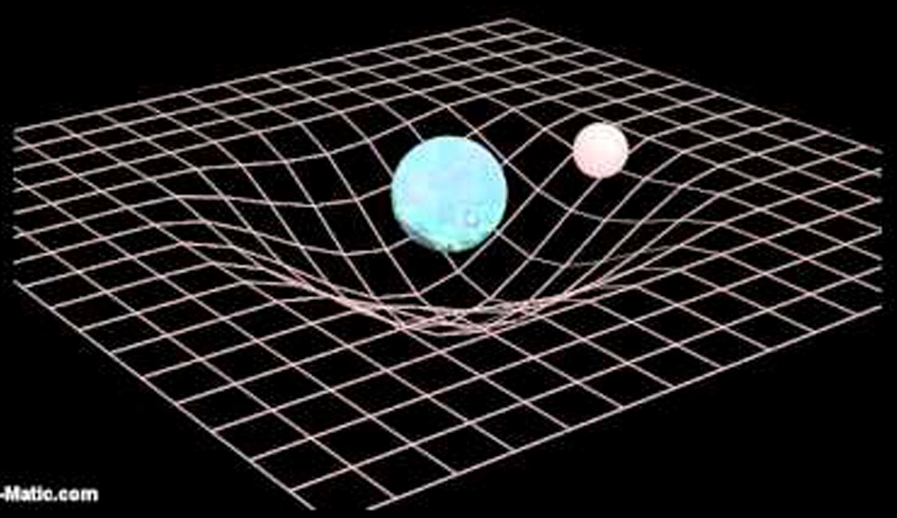

Now imagine that these two massive objects are orbiting each other. This type of quadrupole motion distorts space even further to produce a GW propagating outward at approximately the speed of light. As a result, space that is being acted on by a GW experiences stretching in one direction and simultaneously a contraction in the perpendicular direction, oscillating back and forth:

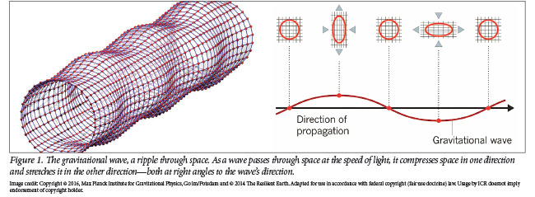

The strength of the GW is measured by strain, or change in length over the original length.
Here is a graphical and pictorial representation of GW formation resulting from the merger of two black holes:
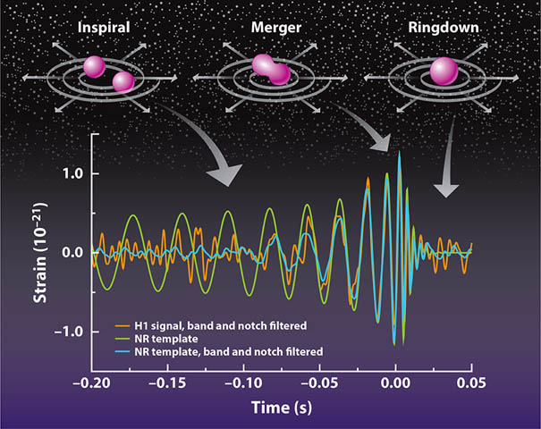

As the black holes orbit each other gravity pulls them in closer. The point at which they merge creates the highest frequency of oscillation and the highest intensity of strain. The result is a gravitational wave that propagates through space in all directions
Detection of such phenomenon is difficult because gravity itself is such a weak force. Only extremely energetic events will produce GWs that can reasonably be detected. Examples include the merging of 2 black holes or 2 neutron stars (both extremely dense objects) or supernovae. Presently, there are three operational detecting facilities: one in Hanford Washington, one in Livingston Louisianna and one in Germany (VIRGO in Italy and KAGRA in Tokyo are under construction). In the United States the facilities are called LIGO for Laser Interferometer Gravitational-wave Observatory. The Michelson Interferometer is an instrument which uses the combined wave patterns of two lasers to infer distortion of spacetime.

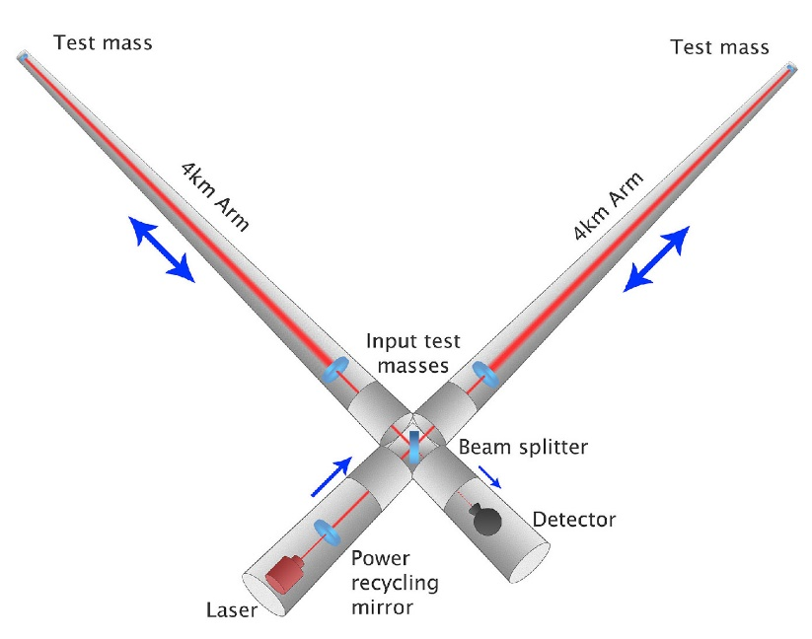

For this experiment a coherent light source generates electromagnetic radiation of a single wavelength. After passing through a beam splitter each wave travels 4 kilometers before being reflected back by mirrors. The reason for creating such a long path for the beams to travel is to reduce the effects of noise. The returning signals combine in amplitude creating an interference pattern picked up by a photodetector. In the absence of a GW the 2 beams should combine constructively to created ringed patterns on the detector. If, however, a passing GW distorts the space in which the beams were traveling, the returning waves will be out of phase. If an oscillating pattern of constructive and destructive interference is observed, then we assume this phenomenon is due to passing gravitational waves. We can confirm this assumption if the same signal in simultaneously detected in another location. If picked up by a third location, we can triangulate its source. This is why multiple detectors are being constructed around the globe, and more are planned for use in space. What’s next for LIGO? Improvements can be made by increasing laser power, reducing noise, installing a squeezed light system, and improved mirrors. More data is needed to solidify our understanding of GR.
By confirming the presence of GWs science takes a giant leap forward in understanding the universe as we know it. This opens the door for multi-messenger astronomy – observing events in space at all wavelengths of electromagnetic radiation as well as gravitational radiation at multiple locations simultaneously. This gives us more information about: the structure of neutron stars, the behavior of black holes, the nature of the strong force, the state of the early universe, and much more.

-- -- -- -- -- -- --
Business:

The Website Committee would like to remind everyone that the old website will be deactivated on December 1st. All information about the society can be found at capecodastronomy.org. We will be spending $180 on the website in February in order to keep it up and running for the next 5 years.

The topic of membership was brought up for discussion. Priorities of the society include identifying people who are interested, capturing them, tracking their involvement and keeping them as long term members. A new effort will be initiated to keep a continuous stream of membership.

Foundation members including Joel, Gus, Mike, Ed, and Bernie have discussed getting a microphone to enhance the quality of conference calls. (Conference calls are free by the way!) UPDATE: A special conference call phone was purchased and donated to the Society and Foundation for their use.

Mike mentioned to us that he is next in line for ownership of the Werner Schmidt Observatory.

The meeting was adjourned at 9:20

Respectfully submitted,
Katie Sisson - Secretary

Star Parties

Winter season once per month "QUARTER MOON SATURDAY STAR PARTIES”, all open to the public, begins September 23rd, 8:30-10:30PM.

From September thru June, we will have one regularly scheduled Star Party each month taking place at 8:30-10:30pm on the Saturday closest to the date of First Quarter Moon (about 7 days old).

From July through August, we will have three or four regularly scheduled Star Parties each month taking place on Thursdays at 8:30-10:30pm.

When the moon is near its First Quarter, the terminator (the line dividing light from dark) is favorable for viewing sunlight or shadow on the sides of craters. This time is also favorable for observing the dark side of the moon occult (visually cover) stars in the sky as the moon moves in its orbit. Depending upon the calendar, we may also be able to observe planets and other celestial objects.

Here is the remaining schedule for “Star Parties” through December, 2017; the public is invited:

Saturday, December 23

POSSIBLE CANCELLATIONS for Star Parties: Cancellations will be very rare since we have lots to do "inside" as well as outside. Even if the forecast is "iffy"; the Staff Leader for the night may elect not to cancel in spite of possible clouds. If clouds arrive after staff and guests have convened, a virtual Star Party will usually take place indoors to include overviews of the sky for that night using computer simulations with our big screen TV, videos of interesting sky events recorded previously, demonstrations and/or training on the use of scopes and other equipment, and consultation/discussions on things astronomical, etc.

However, sometimes a solid forecast for overcast or rain or a storm will result in cancellation of a given Star Party. IF IN DOUBT ABOUT THE WEATHER AND THE STATUS OF A STAR PARTY, CALL THE OBSERVATORY AT 508-398-4765 AFTER 7:45 pm. No answer means the event has been cancelled.

Directions to Dennis Yarmouth HS and Schmidt Observatory

For information on the location of our Dome behind Dennis-Yarmouth High School, click on the purple button "Old Website" and once there, click on "Meeting Location" viewing the two maps that are there: external for the Dome, and internal to locate the high school library where meetings are held.

For meetings, drive in the south entrance road and go around behind the main building. Park in the lot about half way down the building and go in the back door and turn down the hall to your left to find the library.

For Star Parties at the Dome, drive in the north entrance road all the way past the north side of the main high school building, through a gate, and on to park near our Dome.
H&K directions
Please be reminded that Gus Romano or his delegate “host” a dutch-treat dinner gathering for members and friends each CCAS meeting night (before the meeting) at the South Yarmouth Hearth & Kettle restaurant at 5:45pm; (the meetings begin at 7:30 at D-Y.) The speaker for each meeting is always invited. Please join the group to dine and talk about all things interesting, including astronomy, each month before our meeting. The H&K is at 1196 Rt 28, South Yarmouth, about a half mile west of the Station Avenue/Main Street intersection with Rt 28 (stop light).

