Hello Again, CCAS Member and Friend,

I hope you won’t consider a second addendum to our newsletter as Spam…and I’ll try not to make this a habit. But, there are a few items that were “post-newsletter” that need relating, so I hope you’ll bear with an extra email.

1) Elections - As mentioned in the newsletter and the meeting, we have four CCAS officer slots up for election and one CCAF Board slot. Please send in names for these (and self-nomination is OK) by July 1st. Send to Chris Lynch at roadracers@aol.com with the header “CCAS Elections.” We would like to get a good slate, and the positions are not a huge time commitment.

2) Committee meetings – Our four working committees will be meeting, along with the CCAS Officer’s meeting, the third Tuesday of every month from herein. We have some names already, but we also have a need for more participants. If you are interested in one of the committees (listed next), please contact Jim Lynch at jlynch@whoi.edu. Our committees are: 1) Membership/Outreach/Retention, 2) Programs/Content, 3) Communications, and 4) Speaker Program. Again, the duties are not onerous.

3) Venus – After the First Thursday meeting, Jim Head related the good news that US planetary science is again interested in Venus in a big way, and that two new programs are planned for later in this decade. (It also gave a bit of a plug to Brown University… )

"Wednesday afternoon, NASA Administrator and former US Senator Bill Nelson gave a “State of the Agency” address to all NASA employees. I am very pleased to let you know that in his address he announced the selection of two Planetary Science NASA Discovery Mission proposals to go forward for funding and implementation (Discovery Missions are PI-led missions in the $300M category). Both of these missions have as a destination the planet Venus, one an orbiter and one an atmospheric descent probe (https://www.jpl.nasa.gov/news/nasa-selects-2-missions-to-study-lost-habitable-world-of-venus). Both missions, which have been in competition for selection, are headed by Brown graduates. The orbiter, VERITAS, is led by Dr. Sue Smrekar, Brown ScB ‘84, (https://science.jpl.nasa.gov/people/Smrekar/), and the probe, Davinci+, is led by James Garvin, Brown PhD ‘84 (https://science.gsfc.nasa.gov/sed/bio/james.b.garvin).

4) George Silvis wanted to share his observation, after the meeting, that the Sun wasn’t so inactive after all, and that there actually were some large Sudden Ionospheric Disturbances going on! I’ll ask George to show that data at one of our coming meetings.

5) George also shared an AAVSO announcement that should be of broad interest, regarding some free AAVSO webinars and training sessions. The details are below.

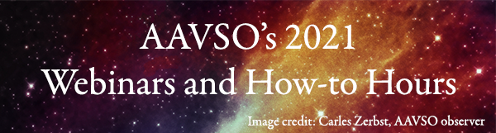

Hello astronomy enthusiast!
AAVSO’s 2021 year-long webinars and How-to Hours, June edition, arrives this Saturday! Each How-to Hour introduces a specific practical aspect of variable star astronomy, while each webinar features one or two figures in astronomy research presenting on their work.
We hope you join us for our free sessions on Zoom! You can attend any or all—each session is separate from the previous one.
June's How-to Hour
This Saturday, the 5th, at 18:00 UT (register here)
Richard Berry (AAVSO Instrumentation & Equipment Observing Section leader;
AAVSO Board, 2nd Vice President)
"Your First Observatory: Keep it simple!"
June's Webinars
Saturday the 12th, at 18:00 UT (register here)
Dr. Dan Milisavljevic (Supernova Early Warning System—SNEWS—Team;
Purdue University)
"Observing the Next Galactic Supernova: Will you be ready?"
Saturday the 26th, at 18:00 UT (register here)
Tom Calderwood (AAVSO Photoelectric Photometry Observing Section leader)
"A Romp with Betelgeuse"
For the year's schedule and details about the featured astronomers and their talks, please go here.
We love being able to offer free education to you and other astronomy enthusiasts! AAVSO is a nonprofit with an aim to enable anyone to pursue their astronomy passions and expand their knowledge. If you are able, we ask you to please consider giving a donation for attending. Many thanks for any contributions, and for joining us!
Thank you to our 2021 Webinar and How-to Hour Gold Sponsor:
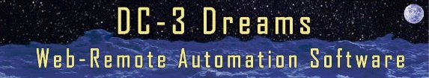
We hope to "see" you there!
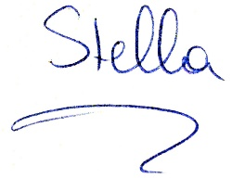
Dr. Stella Kafka
AAVSO Executive Director

Copyright © 2021 American Association of Variable Star Observers, All rights reserved.
You are receiving this email because you opted in to communications from the AAVSO.
Our mailing address is:
American Association of Variable Star Observers
49 Bay State Rd
Cambridge, MA 02138-1203
Add us to your address book

6) ) Our March speaker, Jim Gates, has passed on a link that might be of interest to our members and friends. Jim is a string theorist, and this link explains what he does in layman’s terms.

Hi,
This month, I will be giving a presentation that provides an accessible
view of one of my current research foci.
This presentation
https://www.ictp-saifr.org/strings-outreach-activities/
will be a popular level talk and if you know anyone who might be inte-
rested, please forward the information.
Jim
S.J.Gates, Jr.
Brown Theoretical Physics Center Director,
Ford Foundation Professor of Physics,
Affiliate Professor of Mathematics, and
Watson Institute for International and Public Affairs
Brown University
---------------

All the best,

Jim Lynch, President CCAS

---- ---------- ------

